UK Public Transport Information Profile

A TransXChange profile

for exchanging UK schedule data within the Bus Open Data Digital Service and similar systems

Document Control Log
Date | Modified By | Comment | Version
2020-04-13 | SJR | Initial Draft | v0.1
2020-04-14 | SJR | Added introduction, adjusted layout & pagination. | v0.2
2020-04-30 | SR | Issued for consultation as v1.0 | v1.0
2020-08-09 | SJR | Amendments, expansions and clarifications following DfT review, including additional tables and figures and hence some renumbering. | v1.1
2021-06 | TMR | Clarification and corrections following industry review and inclusion of BODS validator rules. Issued for further industry review. | V1.1a.4

Table of Contents
1 Introduction 7
1.1 Scope 7
1.2 Relationship to TransXChange 7
1.3 Abbreviations 8
1.4 Structure of this document 8
1.5 Credits 9
2 General 10
2.1 General principles 10
2.2 Top Level Elements 10
2.3 Versions 11
2.4 Accessibility information 16
2.4.1 Introduction 16
2.4.2 The VehicleType element 16
2.4.3 Passenger information equipment 18
2.4.4 Vehicle access equipment 19
2.4.5 Wheelchair-specific information 20
2.5 Notes 21
3 Serviced organisations 22
3.1 Introduction 22
3.2 Defining a serviced organisation 22
3.3 Example of a serviced organisation coding in TXC-PTI 27
4 Operators, Garages and Registrations 28
4.1 Introduction 28
4.2 The Operators group 28
4.3 The Operator element 29
4.3.1 Basic structure of the Operator element 29
4.3.2 Example of an Operator coding 32
4.4 Registrations 32
5 Services and Lines 33
5.1 Introduction 33
5.2 The Services group 33
5.3 The Service element 33
5.3.1 Introduction 33
5.3.2 Identifying the service 36
5.3.2.1 Registered services 36
5.3.2.2 Unregistered services 36
5.3.3 Operating dates and patterns 37
5.3.3.1 Use in TXC-PTI 37
5.3.3.2 Examples of correct and incorrect use of OperatingProfile 38
5.3.4 Service operated by multiple operators 41
5.3.5 Standard services 44
5.3.6 Interchanges 45
5.3.6.1 Introduction 45
5.3.6.2 The common interchange group 47
5.3.6.3 The journey pattern interchange group 47
5.3.6.4 Examples of a journey pattern interchange 48
5.3.7 Other elements 48
5.4 The Lines group 50
5.5 The Line element 51
5.5.1 Introduction 51
5.5.2 Identifying the line 52
5.5.3 Line name, line colour and marketing name 53
5.5.4 Describing the line 53
6 Stop points and stop areas 56
6.1 Introduction 56
6.2 Stop points referencing NaPTAN 57
6.3 Stop points not referencing NaPTAN 59
7 Routes and tracks 60
7.1 Introduction 60
7.2 Routes 62
7.3 RouteSections and RouteLinks 63
7.4 Tracks 64
8 Journey timings on standard services 67
8.1 Introduction 67
8.2 The JourneyPattern element 68
8.3 The JourneyPatternSection element 70
8.4 The JourneyPatternTimingLink element 70
8.4.1 Introduction 70
8.4.2 Basic Structure of a JourneyPatternTimingLink 71
8.4.3 Stop definition and wait times 72
8.4.4 Formatting for timetable displays 75
9 Vehicle journeys 77
9.1 Introduction 77
9.2 Basic structure of a vehicle journey 77
9.2.1 Introduction 77
9.2.2 Formatting for timetable displays 80
9.3 The OperatingProfile 81
9.3.1 Basic structure of an OperatingProfile 81
9.3.2 Regular days 83
9.3.3 Periodic days 84
9.3.4 Special days 85
9.3.5 Bank holidays 87
9.3.6 Referencing serviced organisations 89
9.4 Trip timings 91
9.5 Journeys after midnight 93
9.6 Interchanges between vehicle journeys 95
9.6.1 Basic structure of a VehicleJourneyInterchange 95
9.6.2 Example of a vehicle journey interchange 97
9.7 Real-time information 98
9.7.1 Introduction 98
9.7.2 Layover points 99
9.7.3 Dead runs 100
10 Flexible services 103
10.1 Declaring a flexible service 103
10.2 The FlexibleJourneyPattern element 103

List of Figures
Figure 1 - An indicative set of element attributes 12
Figure 2 - The VehicleType structure 16
Figure 3 - The PassengerInfoEquipment element 18
Figure 4 - The AccessVehicleEquipment element 19
Figure 5 - The WheelchairVehicleEquipment element 20
Figure 6 - The Note structure 21
Figure 7 - The ServicedOrganisation element 24
Figure 8 - The Operators structure 28
Figure 9 - The Operator element 29
Figure 10 - The Service element 34
Figure 11 - Excerpt from Service element showing association elements 42
Figure 12 -The StandardService element 44
Figure 13 - The JourneyPatternInterchange element 46
Figure 14 - The Line element 51
Figure 15 - The line description structure 54
Figure 16 - StopPoints and StopAreas in a TXC document 56
Figure 17 - The AnnotatedStopPointRef element 58
Figure 18 – Example of routes and tracks showing different levels 60
Figure 19 - The Routes structure 62
Figure 20 - RouteSection and RouteLink structure 63
Figure 21 - The Track structure 64
Figure 22 - The JourneyPattern structure 68
Figure 23 - Overview of JourneyPatternTimingLink element 71
Figure 24 - The JourneyPatternStopUsage structure 73
Figure 25 - Basic structure of a VehicleJourney 77
Figure 26 - Basic structure of an OperatingProfile 82
Figure 27 - The RegularOperationStructure 83
Figure 28 – The NormalDayPropertiesGroup/PeriodicDayType structure 84
Figure 29 - The structure of special days 86
Figure 30 - The VehicleJourneyTimingLink structure 92
Figure 31 - The VehicleJourneyInterchange element 96
Figure 32 - The OperationalStructure supporting real time elements 98
Figure 33 - The DeadRun structure 101
Figure 34 - The FlexibleService element 103
Figure 35 - The flexible journey pattern structure 104

List of Tables
Table 1 - Usage of top-level elements in TXC-PTI 10
Table 2 - Attributes used for versioning 13
Table 3 - Permitted values for PassengerInfoEquipment 18
Table 4 – Permitted elements for AccessVehicleEquipment 19
Table 5 - Permitted elements for WheelchairVehicleEquipment 20
Table 6 – Permitted elements for ServicedOrganisation 23
Table 7 - Permitted elements for Operator 30
Table 8 - Permitted elements for Service 35
Table 9 - Usage of AssociatedOperators elements 42
Table 10 - Usage of ToBeMarketedWith elements 42
Table 11 - Permitted elements for StandardService 44
Table 12 - Permitted elements in the common interchange group 47
Table 13 - Permitted elements for Line 51
Table 14 - Permitted elements in a LineDescriptionStructure 54
Table 15 - Permitted usage of AnnotatedStopPointRef elements 57
Table 16 - Usage of Route elements 62
Table 17 - Permitted usage of RouteLink elements 63
Table 18 - Permitted usage of Track elements 66
Table 19 - Permitted elements for JourneyPattern 69
Table 20 - Permitted elements in JourneyPatternTimingLink 71
Table 21 - Permitted elements and values in a TXC-PTI JourneyPatternStopUsageStructure 74
Table 22 - Example of a structured timetable 75
Table 23 - Usage of elements in a VehicleJourney 78
Table 24 - Example of a structured timetable 80
Table 25 - Usage of elements in OperatingProfile 82
Table 26 - Permitted elements in VehicleJourneyTimingLink 93
Table 27 - Usage of elements in a VehicleJourneyInterchange 97
Table 28 - Permitted usage of elements within a LayoverPoint 100

- Introduction
  - Scope
The Bus Open Data programme, coming from the Bus Services Act 2017, places a requirement on operators to produce TransXChange (TXC) files containing their timetables as open data. While TXC has been around for many years now, and is a mature standard, there are a large variety of ways in which data can be constructed within the standard. Some of these are more concise than others, and some inadvertently hide simple data in complex constructs. This makes it hard to interpret data, and users have to be able to interpret the full standard in order to accommodate the different ways that data may be written.
Furthermore, there is a high degree of inheritance of elements permissible within TXC, and this can lead to differences in interpretation, as different systems differ in which elements within a block remain as the default, and which are overridden. This can lead to errors which, when coupled with the complexity of some implementations, are then hard to identify and correct.
Additionally, the continued reliance by the industry on TXC v2.1 has led to a number of errors which are more avoidable if later versions are used. In particular, the coding of trips which run after midnight (operational day vs calendar day principles) is often wrong.
As part of the Bus Open Data Service (BODS) programme, the Department for Transport (DfT) has sponsored the creation of a TXC profile to support BODS. The aim of this profile is to specify a consistent use of elements and a consistent way of writing TXC that will be used within BODS and which will lead to a higher quality data set and, at the same time, lower the barriers to entry by users new to TXC.
This profile is set out in this document. Because it has a wider applicability than simply the BODS programme, the profile will be referred to as the public transport information profile. It will be abbreviated as the TXC-PTI profile, or simply TXC-PTI within this document.

  - Relationship to TransXChange
The TXC-PTI profile will be based on TransXChange version 2.4, as this is the updated version that has most traction and that will be specified in the BODS guidance. In particular, the TXC-PTI profile will be based on the “general” schema and not the “registration” schema. This use of the general schema allows freedom to remove elements that would be mandatory in the registration schema, but which are not relevant to TXC-PTI.
It is important to note that the TXC-PTI profile is not a new version of the TXC standard. There is no new “XSD” schema definition file, and anyone creating a TXC v2.4 file will be able to make full use of the standard. All the elements within the schema that are mandatory in the schema will be mandatory in the TXC-PTI profile.
What the profile does, instead, is to specify how that standard is to be used. It specifies additional mandatory elements that are to be used, it specifies which data elements shall not be used, and it specifies which are optional. It also details in many instances how the different elements shall be populated, particularly in relation to identifying and versioning different data elements so as to be consistent.
Validation of data against the TXC-PTI profile will take place in two stages:
- Is the data schema-compliant? This is a straightforward check that checks that the data as submitted is compliant with the basic requirements of the TXC v2.4 general schema. This is an in-built function of XML.
- Is the data TXC-PTI compliant? This is a programmatic check to ensure that the data meets the requirements of this profile, carried out by analysing the data in the TXC document. Bespoke systems are required to carry out these checks, and a validator has been developed by DfT as part of the BODS programme.
In addition to the validator checks BODS carries out data quality tests include some PTI-TXC profile related matters, but most are focused on improving the quality and accuracy of information rather than technical compliance. The Data Quality tests are described in the document found at:
https://publish.bus-data.dft.gov.uk/guidance/data-quality-definitions/
The PTI-TXC profile is an additional set of constraints and clarifications that sit on top of TXC version 2.4. While every care has been taken to ensure compliance with TXC, this document will necessarily need to be read alongside the TransXChange schema guidance document. The most recent published version of this is version 59, which contains information on all versions up to and including TXC v2.5. Elements introduced for v2.5 can be ignored, but users should note that the guidance also contains clarifications and corrections to earlier versions of the schema guidance / standard.

  - Abbreviations
BODS Bus Open Data Service. The DfT Bus Open Data Service programme emerging from Section 18 of the Bus Services Act 2017.
DfT The UK Department for Transport.
EBSR Electronic Bus Service Registration
OTC Office for the Traffic Commissioner. Responsible for the registering and compliance monitoring of local bus services to ensure that operators meet their statutory obligations.
NOC National Operator Code. A unique code, usually four characters, that identifies an operator or operating division of an operator and which should be consistent across all systems. This can be found in the NOC database owned and managed by Traveline.
TIL Traveline Information Limited. A company with overall responsibility for traveline-branded public transport information services in the UK, widely advertised on bus stops and buses.
TXC TransXChange. The UK de facto standard for timetable interchange.
TXC-PTI The TXC Public Transport Information profile, set out in this document.
XML EXtensible Markup Language. The technology used to encode TXC documents.

  - Structure of this document
This document is split into sections which form a logical walk through the TXC schema. The sections are not intended to replicate the order that elements occur within a TXC document.
Examples are provided wherever appropriate. As far as possible these are based on real-world examples but should not be taken as representing the operation of actual services or organisations.
Within the document, summaries are placed at key points. These summaries indicate which are the key mandatory items and which are the optional items. They also highlight any key restrictions identified in the text. Summaries are indicated using coloured icons, and these have the following meanings:

➲ | This summarises key mandatory points from the text. |  | ➲ | This summarises key optional points from the text

It must be emphasised that, with optional elements, there is no requirement to include them in a TXC-PTI document although they are strongly recommended in many instances. The specification nevertheless sets out how these optional elements should be populated, including mandatory sub-elements, when the optional element is present.
The use of ‘Not used’ when describing an element or enumeration signifies that the element should not be used when providing TXC-PTI data
The use of Optional means that the data can be provided, but that any implementation using the TXC-PTI profile will not require the element and consumers cannot rely on its availability.
The TXC-PTI profile is being used by BODS, this has several implementation specific requirements. In addition, the BODS implementation carries out validation of data supplied to the service, some of these validation tests and the results benefit from additional explanation. In both situations they are summarised in this document using a bus icon:

 | This summarises key implementation points for the BODS.

  - Credits
This TXC-PTI profile has been sponsored by the DfT, with extensive contributions from the devolved administrations in Scotland and Wales, the UK bus industry, local transport Authorities, and the UK public transport information community. Their input is gratefully acknowledged.
- General
  - General principles
The TXC-PTI profile has been written with a specific set of principles in mind. The aim is to create a simplified profile, which can be used consistently by all systems / operators and where data is clear and unambiguous data. This will lead to data that is more readily understood by downstream open data users, will lead to a higher take up, easier diagnosis, and hence better applications.
The overriding principle is that data should be stated, once, where is best placed. In TXC there is too much scope for writing a mixture of elements, some of which are inherited, some of which are not. There is merit in re-using data where possible, because this keeps file sizes down, but far too often data has been presented where only some of the information in a particular block has been inherited while some has been overridden. This is particularly true of operating profiles, which define the days / dates when the trips actually run.
A secondary, although still important, principle is that data should be stated unambiguously. There are many elements where, for largely historic reasons, ambiguity or shades of meaning have crept in. TXC-PTI aims to remove this ambiguity so that it is clear what the intent of a set of elements or a particular block intend. Again, this is something which is particularly true of operating profiles although it is by no means the only one.
Finally, a third general principle is that ids shall be provided and defined which a) are persistent from one supply of a TXC-PTI file for given service/line to the next; b) provide uniqueness to any given service and line, such that line 8 in one locality is different from line 8 operated by the same operator in a different locality; and c) make it clear when a particular line is changing from one version to the next, and which line it is that is changing.
The implementation of these principles will be described more fully in the sections that follow.

  - Top Level Elements
The table below gives an overview of the usage of the top level elements (those immediately below the root TransXChange element) within the TXC general schema. For more details see the sections referenced.

Table 1 - Usage of top-level elements in TXC-PTI
Element Name | Data Type | Used in TXC-PTI
ServicedOrganisations | ServicedOrganisationsStructure | Where appropriate. See section 3.
ServiceCalendars | ServiceCalendarsStructure | Not used in TXC-PTI
NptgLocalities | TransXChangeNptgLocalitiesStructure | Not used in TXC-PTI
StopPoints | TransXChangeStopPointsStructure | Yes. Shall be present. See section 6.
StopAreas | StopAreasStructure | Not used
RouteSections | RouteSectionsStructure | Yes. Shall be present. See section 0.
Routes | RoutesStructure | Yes. Shall be present. See section 00.
JourneyPatternSections | JourneyPatternSectionsStructure | Yes. Shall be present. See section 8.30.
Operators | OperatorsStructure | Yes. Shall be present. See section 4.
Services | ServicesStructure | Yes. Shall be present. See section 5.
VehicleJourneys | VehicleJourneysStructure | Yes. Shall be present. See section 9.
Registrations | RegistrationsStructure | Not used in TXC-PTI
SupportingDocuments | SupportingDocumentsStructure | Not used in TXC-PTI

  - Versions
A common problem with TXC documents up to the present has been the incorrect use of codes to encode versioning information within a file, despite TXC elements generally being provided with a set of attributes which allow this information to be correctly represented. This can lead to, for example, confusion as to whether a file contains a new service or simply a new version of an existing service.
TXC-PTI has adopted some general rules about versioning which shall be followed in those elements which support it. The general principle shall be that, wherever possible, ids and codes used within a series of documents to describe a service shall be consistent from document to document, and that sequences of documents shall be identified and tracked through the documents’ version control attributes.

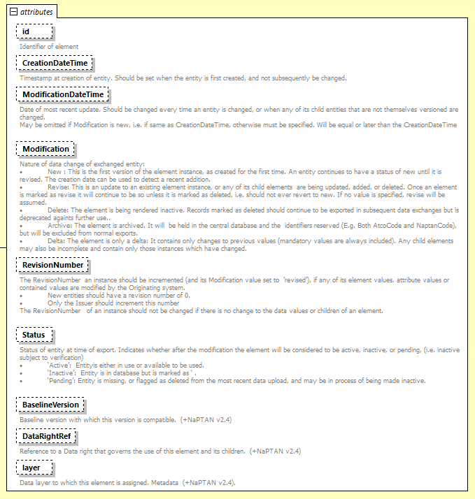
Figure 1 - An indicative set of element attributes
- CreationDateTime shall be populated with the date and time at which the data was first created and shall not be changed in any future version of the same element.
- ModificationDateTime shall be populated with the date and time of the current data. It shall be omitted for the original (version 0) issue of the data but shall be present in all subsequent versions of the same data.
- Modification is a status flag and shall be set to either “New” for the first issue of the data, or to “Revise” for subsequent versions of the same data. No other Modification enumerators shall be used.
- RevisionNumber is a sequence number that shall be 0 for the first issue of the data and that shall increment by 1 for each subsequent version of the data. It is important to note that this revision number is used to track TXC-PTI data from version to version and is independent of any other versioning system. For example, an operator may wish to update operational dates to accommodate school term changes. This would require a change of revision number in the TXC-PTI data, but would be independent of, and not reflect the current value of, the revision number recognised by OTC in respect of the service registration.
- Status is of limited value since data elements (e.g. Service/OperatingProfile) will describe the extent to which data is active. There is therefore no requirement to provide this attribute, and for any conflicts between Status and data, the Status flag shall be ignored.
These are summarised in the table below:

Table 2 - Attributes used for versioning
Attribute Name | Data Type | Used in TXC-PTI
CreationDateTime | dateTime | Yes. Always present and does not change. The date and time of revision number 0.
ModificationDateTime | dateTime | Yes, for all revision numbers other than 0. Omitted otherwise. The date and time of this revision.
Modification | ModificationEnumeration | Yes. Permitted values are:  - New  - Revise
RevisionNumber | RevisionNumberType | Yes. First version is revision number 0. Increment by 1 for each revision thereafter.
Status | StatusEnumeration | Optional
➲
In all cases where it is supported by the element, version control shall be implemented in element attributes.

The validator tests for:
- CreationDateTime being always present and that it remains the same between files submitted with different RevisionNumber.
- ModificationDateTime being newer than CreationDateTime if RevisionNumber is greater than 0.
- Modification is a valid value.
- RevisionNumber for new revisions is larger than the existing published one.
Examples of versioning files in BODS are provided below.
When a new file is supplied to BODS with a new RevisionNumber the previous RevisionNumber file is superseded from the start date of the new file.
When a file with a new RevisionNumber is supplied and the OperatingPeriod has an EndDate specified the new file supersedes the previous file and will continue to be valid until the EndDate is reached or another file with a new RevisionNumber is supplied.
If a revision is submitted for a short period of time, another revision is required to restore the normal service.
This is described visually in the tables:

Where a Service contains more than one Line, versioning is used within individual lines where data for one or more element is being updated. This is helpful to data consumers to identify which elements in a file have changed. For example:

  - Accessibility information
    - Introduction
Early versions of TransXChange schemas had no facility for adding information about vehicles, particularly with respect to wheelchair accessibility and on-board facilities for passengers with visual and/or other impairments. TXC version 2.4 was the first version to include this information, and this was then later extended by TXC version 2.5. Despite the full set of accessibility parameters only being available in v2.5, TXC-PTI can nevertheless make use of the facilities that are in v2.4 to describe the type of vehicle and some of the accessibility features of that vehicle.
➲
Providing information about the accessibility features of the vehicle is optional in TXC-PTI, but is strongly recommended.

Irrespective of the data contained in a TXC-PTI document, there is no obligation on the operator, beyond those set out in law, to provide any of the equipment listed. Operational issues will determine whether any particular trip will operate as stated. The best that the TXC-PTI document can do is indicate what trips are likely to be available to people with reduced mobility or other impairments. As a consequence, the fact that an operator cannot guarantee whether or not a trip is wheelchair accessible (say) should not prevent them supplying data to say that it generally is.

    - The VehicleType element
Information about the accessibility features of a vehicle is achieved through the VehicleType element. This is constructed as shown below.

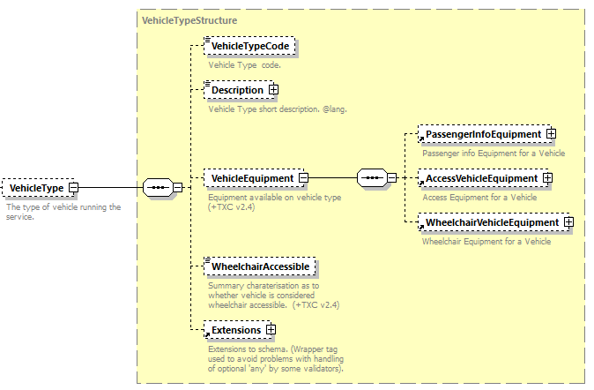
Figure 2 - The VehicleType structure

Each vehicle may have a VehicleTypeCode and a Description; these are operator-defined elements that describe the vehicle. For example, “LFDD” might be the code, and “Low Floor Double Decker” the description. These are textual elements and are only used for visual reference, rather than any direct use in e.g. journey planning, and so can be omitted.
➲
VehicleTypeCode and Description are optional within VehicleType.

Each vehicle may also have a VehicleEquipment element. This element contains sub-elements which provide details about the equipment available for passenger information (PassengerInfoEquipment), the information regarding the accessibility of the vehicle itself, such as whether low floor or fitted with a ramp (AccessVehicleEquipment), and further information on wheelchair spaces, including how many and whether they need pre-booking and how (WheelchairVehicleEquipment). These three sub-elements are described more fully in the sections below.

The main purpose of including a VehicleType element in TXC-PTI is to include information about the vehicle. Within TXC-PTI, therefore, where a VehicleType is provided it shall include a VehicleEquipment element, with at least one of the PassengerInfoEquipment, AccessVehicleEquipment or WheelchairVehicleEquipment sub-elements.
➲

Finally, the VehicleType element also has a Boolean true/false flag, WheelchairAccessible, which states in simple terms whether the vehicle is accessible to passengers in a wheelchair. This flag should be stated explicitly in order to avoid doubt over the meaning of its omission. Note that, given the requirements of the Public Service Vehicle Accessibility Regulations 2000, as of 1st January 2020 it is expected that most vehicles will have this flag set to true.

In TXC-PTI, the VehicleType element shall have a WheelchairAccessible flag which shall be set as appropriate. For most vehicles this will be true.
➲

    - Passenger information equipment
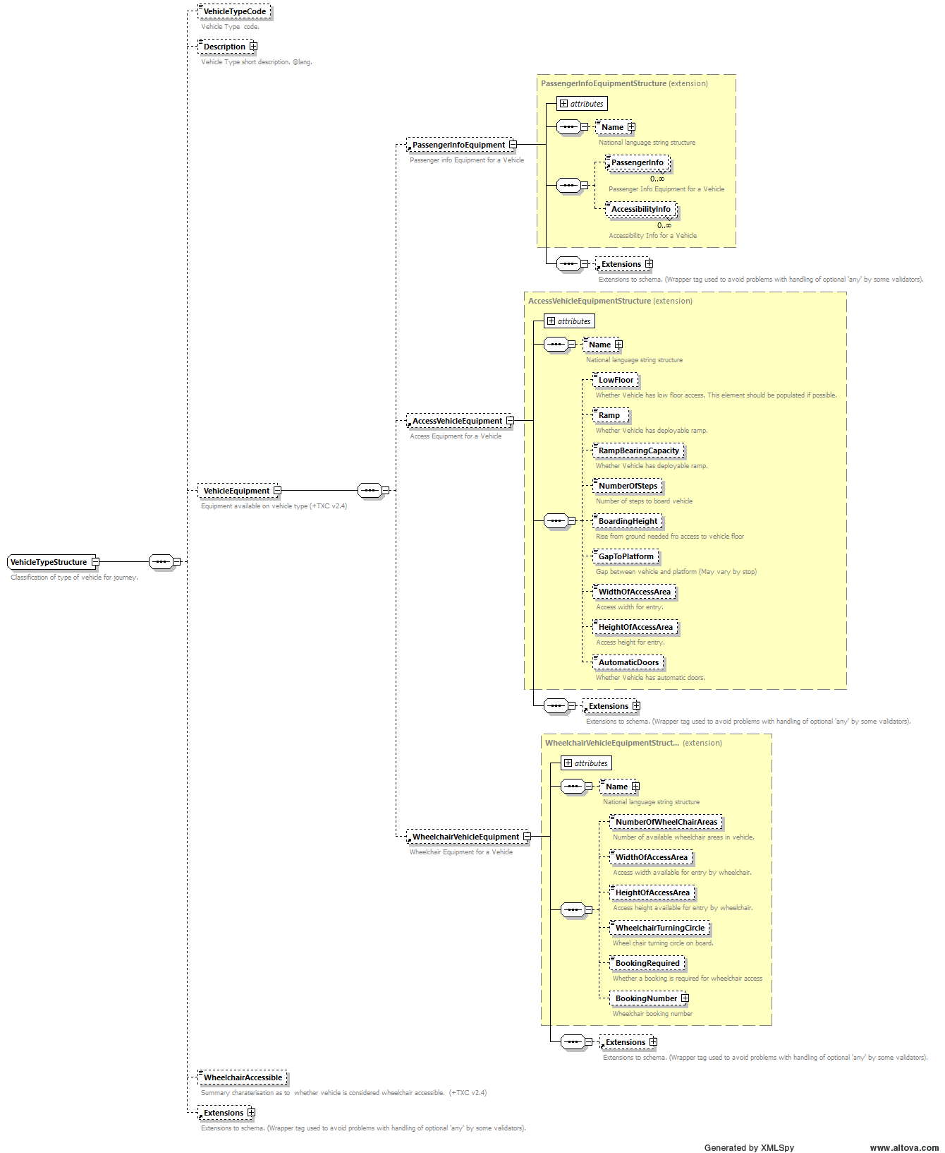
Figure 3 - The PassengerInfoEquipment element

Passenger information equipment describes, through a set of elements which are classified as either passenger or accessibility information, the facilities that the vehicle has for presenting passenger information. The allowable values are shown in Table 3 below.

Table 3 - Permitted values for PassengerInfoEquipment
Group | Permitted Values | Used in TXC-PTI
PassengerInfo | nextStopIndicator | Where appropriate
PassengerInfo | stopAnnouncements | Where appropriate
PassengerInfo | passengerInfoFacility | Optional
PassengerInfo | Other | Optional
AccessibilityInfo | audioInformation | Where appropriate
AccessibilityInfo | audioForHearingImpaired | Where appropriate
AccessibilityInfo | visualDisplays | Where appropriate
AccessibilityInfo | displaysForVisuallyImpaired | Where appropriate
AccessibilityInfo | tactilePlatformEdges | Optional
AccessibilityInfo | tactileGuidingStrips | Optional
AccessibilityInfo | largePrintTimetables | Optional
AccessibilityInfo | other | Optional

For example, a vehicle which has a “next stop” indicator and audio information might be described as follows:

<PassengerInfoEquipment>
  - <PassengerInfo>nextStopIndicator</PassengerInfo>
  - <PassengerInfo>stopAnnouncements</PassengerInfo>
  - <AccessibilityInfo>audioInformation</AccessibilityInfo>
  - <AccessibilityInfo>audioForHearingImpaired</AccessibilityInfo>
</PassengerInfoEquipment>

    - Vehicle access equipment
The AccessVehicleEquipment element describes how the vehicle may be accessed. A number of elements, such as the gap to the platform are not especially useful in a bus context, while others such as low floor and ramp flags are important. Their usage for TXC-PTI is shown in Table 4 below.
Note that for both LowFloor and Ramp, it should be stated explicitly whether these features are present or not. This avoids any doubt which may arise from their omission.

Table 4 – Permitted elements for AccessVehicleEquipment
Element Name | Data Type | Used in TXC-PTI
LowFloor | boolean | Yes. State explicitly whether true or false.
Ramp | boolean | Yes. State explicitly whether true or false.
RampBearingCapacity | Weight | Optional
NumberOfSteps | nonNegativeInteger | Where appropriate
BoardingHeight | Length | Optional
GapToPlatform | Length | Optional
WidthOfAccessArea | Length | Optional
HeightOfAccessArea | Length | Optional
AutomaticDoors | boolean | Optional

Figure 4 - The AccessVehicleEquipment element
For example, a vehicle which has a low floor, but which does not have a deployable ramp for wheelchair access, would be coded as:

<AccessVehicleEquipment>
  - <LowFloor>true</LowFloor>
  - <Ramp>false</Ramp>
</AccessVehicleEquipment>

    - Wheelchair-specific information
The WheelchairVehicleEquipment element provides information on the number and size of wheelchair spaces in the vehicle, together with information on whether or not advance booking is required, and the number to call if it is. Their usage for TXC-PTI is shown in Table 5 below.

Figure 5 - The WheelchairVehicleEquipment element

Table 5 - Permitted elements for WheelchairVehicleEquipment
Element Name | Data Type | Used in TXC-PTI
NumberOfWheelChairAreas | nonNegativeInteger | Where appropriate
WidthOfAccessArea | Length | Optional
HeightOfAccessArea | Length | Optional
WheelchairTurningCircle | Length | Optional
BookingRequired | boolean | Where appropriate
BookingNumber | TelephoneContactStructure | Yes, if BookingRequired is true

For example, a vehicle with 2 wheelchair spaces which require booking may be coded as follows:

<WheelchairVehicleEquipment>
  - <NumberOfWheelChairAreas>2</NumberOfWheelChairAreas>
  - <BookingRequired>true</BookingRequired>
  - <BookingNumber>
  - <TelNationalNumber>01234 567890</TelNationalNumber>
  - </BookingNumber>
</WheelchairVehicleEquipment>

  - Notes
Notes are permitted in various places in TXC-PTI and follow the same structure as in a standard TXC document.
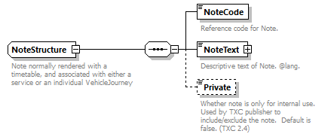
Figure 6 - The Note structure
There are no specific requirements for notes that arise within TXC-PTI, except that:
- notes should not be flagged as private; and
- notes should not encapsulate anything in a text format that is best described through data. This is because consuming systems cannot process textual data without a high degree of effort.
An example of an inappropriate note might include, for example, “Starts 3 minutes earlier at Cefn Coch Inn”, as this should be encoded with suitable stop and timing records.
➲
For TXC-PTI, Notes are optional.

➲
For TXC-PTI, where Notes are used, then these shall not encapsulate information that is best described through data.

The validator tests for dates within the Notes fields and flags a warning if any found as date related data should be properly coded.
Data in Notes should not include any characters or constructs that could be used for SQL injections or other similar purposes. Please do not include any of the following characters in the field: , [ ] { } ^ = @ : ; # $ £ ? % + < > « » \ / | ~ _ ¬
If Notes are used, private element should only be false. If set to true the validator will flag this as an error.

- Serviced organisations
  - Introduction
TXC has a mechanism for holding the dates when organisations, such as schools, are open and closed. This is the ServicedOrganisation. This gives one place where a common set of dates can be defined, and these can then be applied to individual vehicle journeys by a straightforward reference to the serviced organisation code. A ServicedOrganisation also contains a code by which the organisation can be referred, and a description.
This makes a serviced organisation very useful in terms of individual trips. Rather than coding them as operating date records in a VehicleJourney, reference to the ServicedOrganisation allows them to be given context when presenting them to users either as part of a journey plan or via a traditional timetable, for example “operates on Dame Alice Harpur school days only”.
For this reason, TXC-PTI encourages the use of serviced organisations.
However, operators have expressed strong reservations about their ability to manage dates for each organisation as, while there may well be a core of commonality, many different schools and colleges will have different starts and ends to terms and will have different inset (non-teaching) days. Several schools and colleges may be featured on the same trip, and this additionally gives operators difficulties in knowing how to capture the description of when a particular trip runs; it may well be the case that, while one organisation is still open, another has already closed.
Nevertheless, an operator must know whether they are operating a particular trip or not, even if they cannot describe it through a ServicedOrganisation.
For TXC-PTI, then, a ServicedOrganisation is encouraged for the context that it can add, but is not mandatory. However, all trips shall, either through serviced organisations or through dated records, carry the correct dates so that it is unambiguous whether a trip runs or not on any particular day.
➲
In TXC-PTI, the use of ServicedOrganisations is strongly recommended but is not mandatory. It is permitted to use a combination of ServicedOrganisations and dated records within the same TXC-PTI file.
➲
In TXC-PTI, all trips shall be coded to state unambiguously when they operate. If ServicedOrganisations are not used, then appropriate date records shall be used.
The Public Service Vehicles (Open Data) (England) Regulations 2020 require ‘where the service is, or is to be, provided for the purpose of serving a school, college or other educational establishment, the dates of terms for that school, college or other educational establishment;’.

  - Defining a serviced organisation
A ServicedOrganisation has, at first glance, a significant number of elements that can be populated (see Figure 7). TXC-PTI will not use most of these, however, as they are of little use to the public; they carry such information as contact details and classification of a single school, or refer to NaPTAN or NPTG codes that are not public-facing.
Permitted elements and their values in TXC-PTI are as shown in the table below:

Table 6 – Permitted elements for ServicedOrganisation
Element Name |  |  | Data Type | Used in TXC-PTI
OrganisationCode |  |  | OrganisationRefStructure | Yes. Mandated by schema
PrivateCode |  |  | normalizedString | Where appropriate
Name |  |  | NaturalLanguageString | Yes. Meaningful name of organisation e.g. “College of West Anglia”, “Staffordshire schools”
PostalAddress |  |  | UKPostalAddressStructure | Optional
ContactTelephoneNumber |  |  | TelephoneContactStructure | Optional
ContactPerson |  |  | normalizedString | Optional
EmailAddress |  |  | EmailAddressType | Optional
WebSite |  |  | anyURI | Optional
FurtherDetails |  |  | normalizedString | Optional
ServicedOrganisationClassification |  |  | ServicedOrganisation  ClassificationEnumeration | Where appropriate
NatureOfOrganisation |  |  | NaturalLanguageString | Optional
PhaseOfEducation |  |  | NaturalLanguageString | Optional
WorkingDays |  |  | DatePatternStructure | Yes. Shall be included
 | DateRange | StartDate | StartDateType | Yes. State explicit start date
 | DateRange | EndDate | EndDateType | Yes. State explicit end date. Shall not be omitted.
 | DateRange | Description | NaturalLanguageString | Where appropriate
 | DateRange | Provisional | boolean | Where appropriate. True for provisional dates, omitted otherwise.
 | DateRange | DateClassification | DatePatternClassification  Enumeration | Not used
Holidays |  |  | DatePatternStructure | Must not be used. All days which are not defined as working days are considered holidays.
ParentServicedOrganisationRef |  |  | ServicedOrganisationRef  Structure | Optional
AdministrativeAreaRef |  |  | AdministrativeAreaRef  Structure | Optional
NptgDistrictRef |  |  | NptgDistrictCodeType | Optional
AnnotatedNptgLocalityRef |  |  | AnnotatedNptgLocalityRef  Structure | Optional
LocalEducationAuthorityRef |  |  | LocalEducationAuthority  CodeType | Optional

OrganisationCode is mandated by the schema. There is a recommendation in the schema that this should be the reference number of the school, as allocated by the administrations in the devolved governments, however this is not required by TXC-PTI. Firstly, a textual code can be more meaningful (e.g. COWA = College of West Anglia), and secondly, as has already been noted, a set of dates could cover multiple organisations.
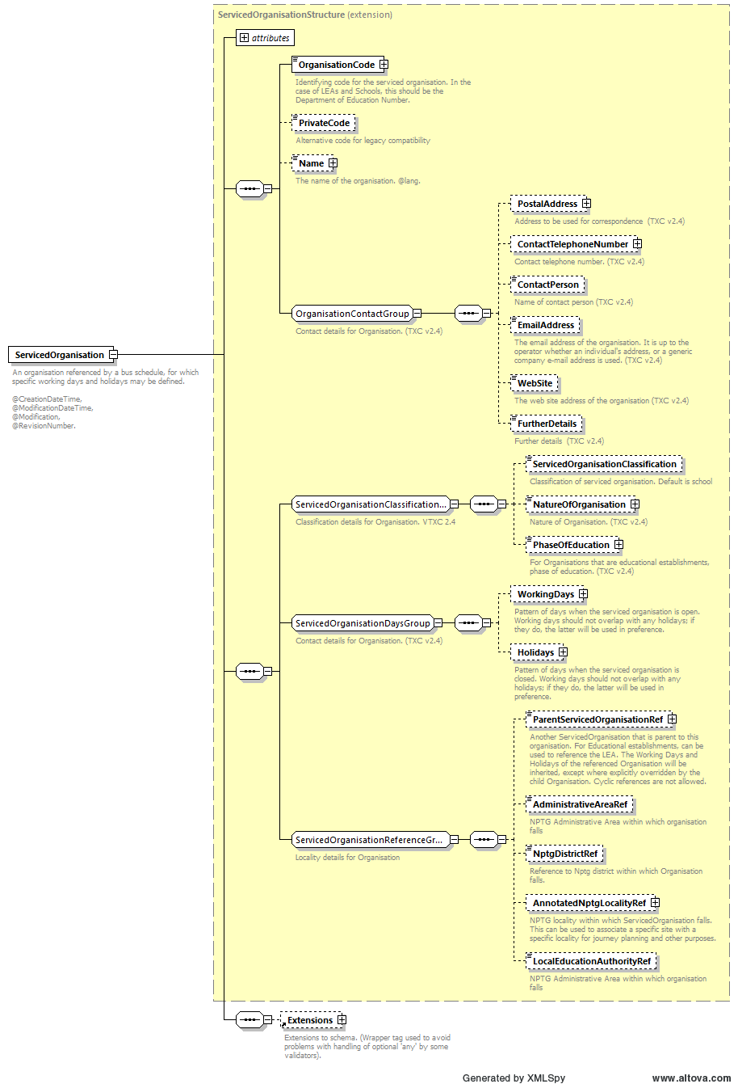
Figure 7 - The ServicedOrganisation element
Name shall be provided, and shall be a meaningful name for the organisation, or group of organisations, being referenced. For example, “College of West Anglia” or “Staffordshire schools”.
ServicedOrganisationClassification may be provided if additional context is required. This is an enumeration that describes the type of establishment, e.g. “school”, “factory”, etc. However, not all systems will recognise or use this.
WorkingDays provides a series of date ranges when the organisation is open. This date range:
- shall have an inclusive StartDate;
- shall have an inclusive EndDate;
- may have a Description to give some context to the date range, although a description is not mandatory in TXC-PTI; and
- may describe a date range as Provisional, although such date ranges must be replaced with actual date ranges prior to the operation of the service.
Note that Holidays shall not be provided. Providing both working dates and holiday dates might seem like a benefit, but there have been instances of overlapping date ranges, and strange encodings e.g. where a service is said to not run in the holidays of an organisation. This can lead to confusion and misinterpretation of the data.
In TXC-PTI, therefore, only WorkingDays shall be defined, and all other days that are not WorkingDays shall be assumed to be holidays. This means that, in a ServicedOrganisationDayType within an operating profile, trips which only operate on working days will be encoded as DaysOfOperation/WorkingDays, while trips which only operate during the holidays will be encoded as DaysOfNonOperation/WorkingDays. It is recommended, however, that any presentation to the user avoids negative descriptions such as “this trip does not operate on the working days of X” but presents it instead with a positive description such as “this trip operates during holidays of X.”
To assist with clarity and simplicity of understating when trips are operating it is suggested that the use of a WorkingDays range for each half term for education establishments is helpful.
See section 9.3 for more details of the OperatingProfile element, and in particular the relationship between the working dates and the regular days of operation in section 9.3.6.
➲
In TXC-PTI, where a ServicedOrganisation is included, it shall be given a code, a meaningful name, and working dates when the organisation is open. Holiday dates shall not be provided; all non-working dates shall be assumed to be holidays.
Name is required to be at least 5 characters. This is to ensure that meaningful names are used for example “College of West Anglia” or “Staffordshire schools”. Shortenings such as SCH should not be used as they do not make it possible to understand the actual organisation being referred to.
At least one WorkingDays range needs to be provided otherwise the validator will report an error.
When providing Provisional dates if the Startdate for WorkingDays is less than or equal to the current date then the validator will report an error as Provisional dates have to be in the future.
If Holidays is provided, then the validator will report an error.
It is important to ensure continued compliance with the requirement to publish dates of operation for a service. Where a Service uses ServicedOrganisaiton and new or updated WorkingDays are available from the organisation data published on BODS will need to be updated to reflect the latest known WorkingDays.

  - Example of a serviced organisation coding in TXC-PTI
The following is an example of how a ServicedOrganisation may be coded and used within a TXC-PTI document. For further details about how the data is encoded in an OperatingProfile, please see section 9.3.
<ServicedOrganisation>
  - <OrganisationCode>BurCol</OrganisationCode>
  - <Name>Burnley College</Name>
  - <WorkingDays>
  - <DateRange>
      - <StartDate>2019-04-22</StartDate>
      - <EndDate>2019-05-24</EndDate>
  - </DateRange>
  - <DateRange>
      - <StartDate>2019-06-03</StartDate>
      - <EndDate>2019-06-28</EndDate>
  - </DateRange>
  - </WorkingDays>
</ServicedOrganisation>
...
<VehicleJourneys>
  - <VehicleJourney SequenceNumber="1">
  - <PrivateCode>120MFBP03:O:1</PrivateCode>
  - <OperatingProfile>
      - <RegularDayType>
        - <DaysOfWeek>
          - <Monday/>
          - <Tuesday/>
          - <Wednesday/>
          - <Thursday/>
          - <Friday/>
        - </DaysOfWeek>
      - </RegularDayType>
      - <ServicedOrganisationDayType>
        - <DaysOfOperation>
          - <WorkingDays>
            - <ServicedOrganisationRef>BurCol</ServicedOrganisationRef>
          - </WorkingDays>
        - </DaysOfOperation>
      - </ServicedOrganisationDayType>
  - </OperatingProfile>
  - ...
  - </VehicleJourney>
  - ...
</VehicleJourneys>

- Operators, Garages and Registrations
  - Introduction
In a TransXChange document, every trip that operates is operated by an Operator. Given that TXC is most often used for bus and coach data, an Operator is usually a registered bus or coach operator in possession of a valid, current, OTC-issued “O-licence”. However, it is also possible that an Operator is a not-for-profit community transport association with a “Section 22” permit, or an operator of another mode. The schema is agnostic as far as the type of operator is concerned.
  - The Operators group
The Operators group in TXC is a grouping element that can hold one or multiple operator records, classified into different operating categories: Operator or LicensedOperator. There is no difference in the content of these two categories; it is simply that LicensedOperator contains some additional mandatory elements above what is required for an Operator. However, a LicensedOperator includes some mandatory information that is better sourced from other sources, and hence only Operator shall be used.
The Bus Open Data requirements that will be supported by the TXC-PTI profile are for each operator to be responsible for their own data. Therefore, an Operators group shall only contain a single instance of Operator.
➲
For TXC-PTI, an Operators group shall contain only a single Operator, and not a LicensedOperator.
If more than one Operator or a LicencedOperator is included then the validator will report an error

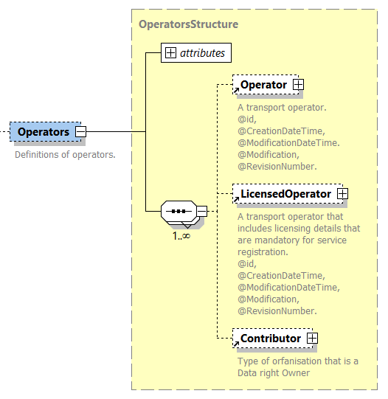
Figure 8 - The Operators structure
  - The Operator element
    - Basic structure of the Operator element
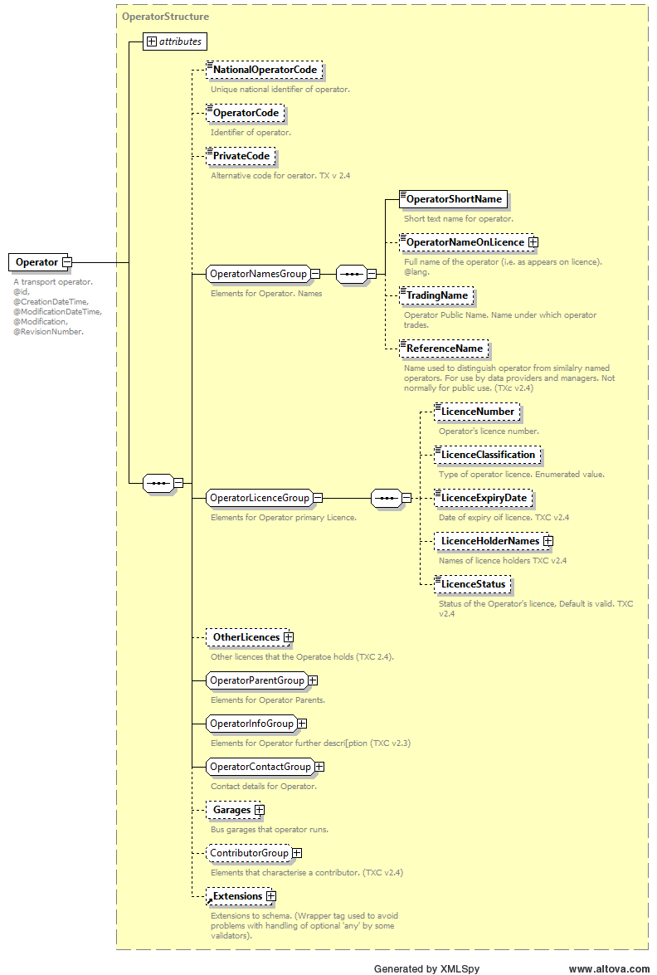
Figure 9 - The Operator element
The Operator element contains a large amount of information about the operator, most of which is best obtained from other sources by means of referenced identities. There is no need to replicate it within the TXC, and this also avoids the risk that conflicting information is provided; there needs to be a single source of truth. The Operator element therefore only needs to contain references which link to those external sources, and such information as is either mandatory in the schema or which cannot necessarily be inferred from external sources.
Each Operator shall have an id attribute. This is an internal reference only and is only used to reference other elements within the TXC document. The format of this id is not mandated by the TXC-PTI profile, although it is recommended that this be that national operator code, which is both human-readable and meaningful.

The Operator elements shall be used as set out in Table 7.

Table 7 - Permitted elements for Operator
Element Name |  |  | Data Type | Used in TXC-PTI
NationalOperatorCode |  |  | NationalOperatorCodeType | Yes. Shall be included
OperatorCode |  |  | OperatorCodeType | Where appropriate
PrivateCode |  |  | PrivateCodeType | Optional
OperatorShortName |  |  | OperatorShortNameType | Yes. Mandated by the schema, although limited by the schema to 24 characters
OperatorNameOnLicence |  |  | NaturalLanguageString | Where appropriate to aid readability / traceability.
TradingName |  |  | OperatorTradingNameType | Where appropriate
ReferenceName |  |  | normalizedString | Optional
LicenceNumber |  |  | OperatorLicenceNumberType | Yes. Shall be included. Licence number specific to the service in this TXC document.
LicenceClassification |  |  | OperatorLicenceEnumeration | Optional
LicenceExpiryDate |  |  | date | Optional
LicenceHolderNames |  |  | LicenceHolderNamesStructure | Optional
LicenceStatus |  |  | LicenceStatusEnumeration | Optional
Other Licences |  |  | OperatorLicencesStructure | Optional
ParentOperatorRef |  |  | AnnotatedOperatorRefStructure | Optional
UltimateParentRef |  |  | AnnotatedOperatorRefStructure | Optional
PrimaryMode |  |  | VehicleModesEnumeration | Optional
EbsrUser |  |  | Boolean | Optional
TravelineOwner |  |  | RegionShortCodeEnumeration | Optional
RegionalOperatorRefs |  |  |  | Optional
Note |  |  | NaturalLanguageString | Optional
EnquiryTelephoneNumber |  |  | TelephoneContactStructure | Optional
ContactTelephoneNumber |  |  | TelephoneContactStructure | Optional
ContactFaxNumber |  |  | TelephoneContactStructure | Optional
ContactPerson |  |  | normalizedString | Optional
CustomerServicesTelephoneNumber |  |  | TelephoneContactStructure | Optional
OperatorAddresses |  |  | OperatorAddressesStructure | Optional
EmailAddress |  |  | EmailAddressType | Optional
WebSite |  |  | anyURI | Optional
Garages |  |  | GaragesStructure | Where appropriate to show dead runs for real time information, and not otherwise.
 | Garage | GarageCode | GarageCodeType | Mandatory if garages are included
 | Garage | GarageName | NaturalLanguageString | Where appropriate
 | Garage | ContactNumber | TelephoneContactStructure | Optional
 | Garage | Address | UKPostalAddressStructure | Optional
 | Garage | ContactPerson | normalizedString | Optional
 | Garage | Location | LocationStructure | Optional
PolicyStatus |  |  | PolicyStatusEnumeration | Optional
ContributorClassification |  |  | ContributorClassification  Enumeration | Optional
DataRights |  |  | DataRightsStructure | Not used as all data provided to BODS is governed by the Bus Services Act 2017.

NationalOperatorCode is mandatory. This code shall refer back to the appropriate code held within the National Operator Code database (NOC) maintained and operated by Traveline Information Limited (TIL) or its successor organisations. The publicly accessible NOC database shall hold all the appropriate details for the operator including, but not limited to, contact details, websites, public-facing operator identities, etc. as appropriate. The NOC code shall be used as the key for accessing this information, without it having to be duplicated within the TXC document except as outlined below.
OperatorCode is optional, although it may be populated for compatibility with other systems
OperatorShortName is mandated by the schema. Where possible this should match the Operator Public Name field in NOC.
TradingName shall be provided, where this is different from the name given in NOC.
LicenceNumber shall be provided where applicable. Where an operator has more than one O-licence, the licence number provided shall be the licence number relevant to the service being described in the TXC document. Details about the licence shall be obtained via reference to OTC, and not to other sources, although OperatorNameOnLicence may be provided to aid human readability of the TXC document.
Garage entries in the Garages group may be provided, but only inasmuch as they are required for use in e.g. dead runs in VehicleJourneys and for use in real time systems. Otherwise, this information shall be left empty.
No other elements shall be populated for Operator. This includes, specifically, any contact information contained within the OperatorContactGroup as this information shall be taken from NOC referenced by the NationalOperatorCode.
➲
For TXC-PTI the operator element shall include NationalOperatorCode, OperatorShortName, and shall also include TradingName, LicenceNumber and Garages as appropriate. Other elements are optional or not used.

The NationalOperatorCode provided should be the most granular NOC for the operator (e.g. FESX for First Group’s bus operations in Essex)
If Garages structure is provided it must include at least one Garage.

    - Example of an Operator coding

<Operator id="EYMS">
  - <NationalOperatorCode>EYMS</NationalOperatorCodeCode>
  - <OperatorShortName>East Yorkshire Buses</OperatorShortName>
  - <OperatorNameOnLicence>East Yorkshire Motor Services</OperatorNameOnLicence>
  - <LicenceNumber>PB0000328</LicenceNumber>
  - <Garages>
  - <Garage>
      - <GarageCode>HU</GarageCode>
    - <GarageName>Hull</GarageName>
  - </Garage>
  - </Garages>
</Operator>

  - Registrations
In EBSR documents, a TXC Registrations block is included to replicate the information that would be contained on the paper registration. However, for TXC-PTI which is public-facing information, this information is superfluous and adds nothing to the quality of the open data. For this reason, the Registrations block shall not be included in a TXC-PTI document.
There is merit in referencing the OTC registration reference, however, for traceability and completeness purposes, but this shall be encoded as part of the ServiceCode within the Services element (see 5.2).
➲
The Registrations group shall not be included within a TXC-PTI compliant document.
If a Registrations group is included then the validator will report an error.

- Services and Lines
  - Introduction
In the UK, the label “service” is often used in common terminology but means different things to different people, but in data it is important to make the distinction.
In TXC, this distinction is made using the terms “service” and “line”, where:
- A LINE is a collection of vehicle journeys (trips) that share some high degree of commonality of route and timings, and which are all known by the same LINE NAME. Examples are “1”, “1B”, “100”, “calverton connection”, etc. (there is no requirement for a LINE NAME to include a number)
- A SERVICE is a collection of LINEs that together make up a coherent set of vehicle journeys usually running over geographically similar routes although this isn’t a requirement. For example, consider a service “1/1A”, where line “1” operates “A to B direct” and line “1A” operates “A to B via C”, and together they make up the complete service between A and B.
Note that this description and example should be taken as illustrating the terms and the concept only.

  - The Services group
The Services group in TXC is a group that holds one or more Service elements in a ServicesStructure. It has been common practice in some operators’ data to submit several services within the same TXC document. However, there is often little consistency in how these are grouped and, often, multiple services contain single lines where the intent would be better represented by a single service with multiple lines. Additionally, including too much information in a single TXC document can make it harder to fault-find a single service due to the inclusion of data not related to that service. In TXC-PTI, therefore, the permitted number of services in a single TXC document shall be limited.
➲
In TXC-PTI, the Services group shall only contain a single Service element.

If more than one Service element is provided then the validator will raise an error.

  - The Service element
    - Introduction
The Service element in TXC describes the service, the lines that it comprises, and provides other information about the default operation of the service. Certain elements are schema-mandated, however TXC-PTI will provide rules as to the ways that a number of these shall be populated.
As stated earlier, there shall only be one Service element in TXC-PTI file. This applies even to different versions of the same service, because a duplication would require different keys to be contained within the data, which would then break the requirement for the keys to be consistent from version to version.
A Service shall be versioned, as described in section 2.3 above.

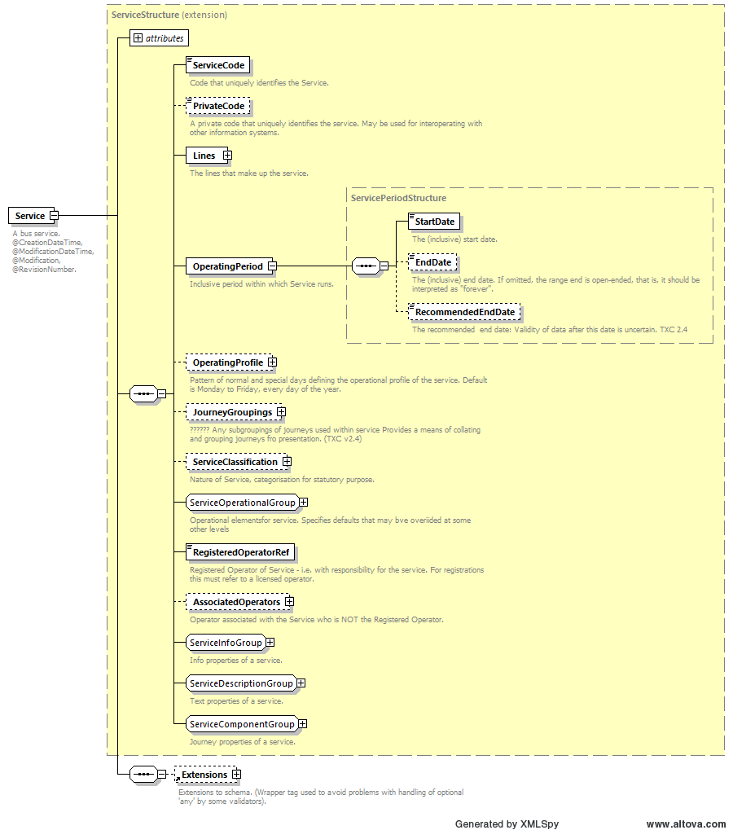
Figure 10 - The Service element

Mandatory, optional and unused elements within a Service are as shown in the table below. Detailed usage of the elements is described more fully in the sections which follow.

Table 8 - Permitted elements for Service
Element Name | Data Type | Used in TXC-PTI
PrivateCode | PrivateCodeType | Where appropriate
Lines |  | Schema mandated. See 5.4.
OperatingPeriod | ServicePeriodStructure | Schema mandated. See 5.3.3.
OperatingProfile | OperatingProfileStructure | Yes, if defining all or the majority of trips in full. Omitted otherwise. See 5.3.3.
JourneyGroupings | JourneyGroupingsStructure | Not used
ServiceClassification | ServiceClassificationStructure | Not used
TicketMachineServiceCode | TicketMachineServiceCodeType | Where appropriate to define it at service level rather than individual vehicle journey level. See 9.7
VehicleType | VehicleTypeStructure | Where appropriate. See 5.3.7
RegisteredOperatorRef | OperatorRefStructure | Schema mandated. Refers to an operator id defined in the Operator element.
AssociatedOperators | OperatorRoleStructire | Where appropriate. See 5.3.4
ServiceHasMirror | boolean | Optional
StopRequirements | StopRequirementsStructure | Optional
Mode | VehicleModesEnumeration | Where appropriate. See 5.3.7
PublicUse | boolean | Yes. Shall be included. True if service is available to the public, false if not. See 5.3.7
ServiceAvailability |  | Optional
Express | boolean | Optional
CommercialBasis | ServiceCommercialBasis  Enumeration | Where appropriate. See 5.3.7
Description | NaturalLanguageString | Optional
Note | NoteStructure | Where appropriate. See 5.3.7
SchematicMap | ImageDocumentType | Not used
MarketingName | normalizedString | Where appropriate. See 5.3.7
ToBeMarketedWith | ToBeMarketedWithStructure | Where appropriate. See 5.3.4
StandardService | StandardServiceStructure | Where appropriate. Shall be included for non-flexible services. See 0
FlexibleService | FlexibleServiceStructure | Where appropriate. Shall be included for flexible services. See 10
Direction | ServiceDirectionEnumeration | Not used
JourneyPatternInterchange | JourneyPatternInterchange  Structure | Where appropriate. See 5.3.6

    - Identifying the service
      - Registered services
The ServiceCode element uniquely identifies the service.
For registered services within TXC-PTI this shall be the registration reference as given when the service is registered with OTC. This takes the form of the “O-licence” number, a forward slash, and a sequential number; for example, PF0000459/134 is the registration reference for Stagecoach service 3 in Bedford. Using the registration reference for the ServiceCode in this way facilitates traceability and permits other operations such as completeness checks to be carried out.
While a forward slash is not a reserved character in XML, to avoid confusion and to aid readability the ServiceCode in TXC-PTI shall replace the forward slash in the registration reference with a colon.

<Service>
  - <ServiceCode>PF0000459:134</ServiceCode>
  - ...
</Service>

      - Unregistered services
While Bus Open Data is directed initially towards operators of registered bus services, the TXC-PTI profile is intended to fulfil a wider use. Data for unregistered services such as community transport services and coach services therefore needs to ensure that ServiceCode is a) unique; and b) consistent from version to version in the same way that it is for registered services. Unregistered services, though, do not have an OTC registration reference that can be used.
In TXC-PTI, uniqueness for unregistered services shall be ensured by formatting the ServiceCode as follows:
- Start with the letter code “UZ” to denote an unregistered service. The second letter is a placeholder in case a future version of this profile requires to split out unregistered codes e.g. by region in a similar way to OTC’s “PF”, “PH”, etc. O-licence codes.
- Follow with three zeros and then the 4-letter NOC code of the operator (or four zeroes if the NOC code is three letters, or five zeros if the NOC code is two letters).
These two elements combined provide a format which is the same length and styling as the O-licence for a registered service.
- Follow that with an operator-generated reference number that is unique for that service, and which shall persist from version to version of the same service. Separate this with a colon, as is the case for the registered services.
For example, West Norfolk Community Transport may choose to encode their “Go To Town” service 32 like this:

<Service>
  - <ServiceCode>UZ000WNCT:GTT32</ServiceCode>
  - ...
</Service>

Note that the last part of the code is entirely down to the operator. There is no requirement to include the line number, as shown in the example, as the line number or name will be included in the id of the Line - see section 0 below.
To be clear, this method of creating a service code only applies to services which do not have an OTC service registration reference. Where a service has an OTC service registration reference then this shall be used instead, as set out in section 5.3.2.1,even if the service is not legally required to be registered.
➲
In TXC-PTI, where a service has an OTC service registration reference then the ServiceCode shall be that service registration reference, with the forward slash replaced with a colon.
Where a service is unregistered, and only then, operators shall use a similar format with the O-licence number being replaced with a pseudo-reference made from “UZ” plus the operator’s NOC and a unique reference as described above.
The BODS service requires the ServiceCode to be in the structure described to allow data to be referenced to the OTC registrations data as part of the compliance validation process for operators providing data to BODS. The inclusion of prefixes and suffixes are now allowed.
ServiceCode must remain consistent when supplying updated data to ensure that version management works as described in section 2.3.
If ServiceCode is not of the correct format, then the validator will report an error.

    - Operating dates and patterns
      - Use in TXC-PTI
In TXC-PTI, the overall dates of operation of the service shall be defined, as with the full TXC schema, by the mandatory OperatingPeriod element. As a minimum, an OperatingPeriod requires a StartDate. Where the last date of operation of the services is known (for example, because the service is terminating in the near future, there is an impending change, or because the service being described only operates for a limited period), then an EndDate shall also be provided. If the service is expected to run “until further notice” then the EndDate shall be omitted.
In TXC-PTI, the use of an EndDate in the far distant future to represent an effective “until further notice” operation shall not be permitted. An EndDate shall only describe the actual end date of a service.
Between these (inclusive) start and end dates, the default operation is described by the OperatingProfile. In standard TXC documents, this is predominantly used in one of two ways:
- To describe the overall operation of the service, e.g. “Mondays to Sundays” for a seven-day service, even though different timetables may operate Mondays to Fridays, Saturdays, and Sundays; or
- To describe the majority of trips e.g. “Mondays to Fridays” even though there are also trips which run on Saturdays and on Sundays.
A principle behind TXC-PTI is that data which is declared as a default and then over-ridden in a more specialised element should be avoided wherever possible, as this leads to confusion. On that basis, it is preferable that the Service/OperatingProfile element should be omitted. However, this does mean that the size of files could expand dramatically when there is no need to because all OperatingProfile information has to be encoded into individual VehicleJourney elements.
For TXC-PTI, therefore, this principle can be relaxed for OperatingProfile, so long as the operating profile completely defines the operations of the largest number of trips in full (e.g. it defines Mondays to Fridays excluding Bank Holidays). Individual VehicleJourney elements then have either:
- no OperatingProfile, because they follow the default pattern; or
- a complete set of OperatingProfile elements which completely replace the default pattern, and which describe in full when that VehicleJourney runs.
Where used in a Service, the OperatingProfile shall follow the rules described in section 9.3.
➲
In TXC-PTI:
- the OperatingPeriod shall only include an EndDate if the service has an actual end date.
- The Service/OperatingProfile may only describe, in full, the default days of operation and non-operation of the service, which shall be applicable to the majority of the trips. Otherwise, it shall be omitted.
- Service/OperatingProfile may not describe the overall operation of the service if the majority of trips do not operate this way.
Where an EndDate it supplied must reflect actual end dates for contracts or known service end date. The longest likely contract for a service is 10 years, the validator therefore checks that an end date is no more than 4026 days (11 years) after the start date.

      - Examples of correct and incorrect use of OperatingProfile

<Services>
  - <Service>
    - <ServiceCode>PA0000123:1</ServiceCode>
    - ...
    - <OperatingPeriod>
      - <StartDate>2020-09-01</StartDate>
    - </OperatingPeriod>
    - <OperatingProfile>
      - <RegularDayType>
        - <DaysOfWeek>
          - <Monday>
          - <Tuesday>
          - <Wednesday>
          - <Thursday>
          - <Friday>
        - </DaysOfWeek>
      - </RegularDayType>
    - </OperatingProfile>
    - ...
  - </Service>
</Services>
<VehicleJourneys>
  - <VehicleJourney>
    - ...
    - <!-- No operating profile – all trips run Monday to Friday -->
  - </VehicleJourney>
</VehicleJourneys>

The XML excerpt above shows a service that is defined as running on all weekdays. There are no OperatingProfile elements in the VehicleJourney and so the individual trip also runs on all weekdays.
It would also have been valid to omit the OperatingProfile from the service altogether and to place it in the VehicleJourney only:

<Services>
  - <Service>
    - <ServiceCode>PA0000123:1</ServiceCode>
    - ...
    - <OperatingPeriod>
      - <StartDate>2020-09-01</StartDate>
    - </OperatingPeriod>
    - ...
  - </Service>
</Services>
<VehicleJourneys>
  - <VehicleJourney>
    - ...
    - <!-- All trips run Monday to Friday defined in vehicle journey -->
    - <OperatingProfile>
      - <RegularDayType>
        - <DaysOfWeek>
          - <Monday>
          - <Tuesday>
          - <Wednesday>
          - <Thursday>
          - <Friday>
        - </DaysOfWeek>
      - </RegularDayType>
    - </OperatingProfile>
    - ...
  - </VehicleJourney>
</VehicleJourneys>

The XML excerpt below is valid showing how the majority of trips match the coding in the service, even though there are additional trips on other weekdays. Here, the majority of the trips are Monday to Friday trips, which do not have OperatingProfile elements in the VehicleJourney, and only the trips which differ have OperatingProfile elements

<Services>
  - <Service>
    - <ServiceCode>PA0000123:1</ServiceCode>
    - ...
    - <OperatingPeriod>
      - <StartDate>2020-09-01</StartDate>
    - </OperatingPeriod>
    - <OperatingProfile>
      - <RegularDayType>
        - <DaysOfWeek>
          - <Monday>
          - <Tuesday>
          - <Wednesday>
          - <Thursday>
          - <Friday>
        - </DaysOfWeek>
      - </RegularDayType>
    - </OperatingProfile>
    - ...
  - </Service>
</Services>
<VehicleJourneys>
  - <VehicleJourney>
    - ...
    - <!-- No operating profile –trip runs Monday to Friday -->
  - </VehicleJourney>
  - <VehicleJourney>
    - ...
    - <!-- No operating profile – trip run Monday to Friday -->
  - </VehicleJourney>
  - <VehicleJourney>
    - ...
    - <!—Additional trip on Saturday defined in vehicle journey -->
    - <OperatingProfile>
      - <RegularDayType>
        - <DaysOfWeek>
          - <Saturday>
        - </DaysOfWeek>
      - </RegularDayType>
    - </OperatingProfile>
    - ...
  - </VehicleJourney>
</VehicleJourneys>

Finally, the following excerpt is not valid since no trips runs Monday to Saturday. This should have been encoded in one of the forms shown above.

<Services>
  - <Service>
    - <ServiceCode>PA0000123:1</ServiceCode>
    - ...
    - <OperatingPeriod>
      - <StartDate>2020-09-01</StartDate>
    - </OperatingPeriod>
    - <!-- Defines a Monday to Saturday service -->
<OperatingProfile>
      - <RegularDayType>
        - <DaysOfWeek>
          - <Monday>
          - <Tuesday>
          - <Wednesday>
          - <Thursday>
          - <Friday>
          - <Saturday>
        - </DaysOfWeek>
      - </RegularDayType>
    - </OperatingProfile>
    - ...
  - </Service>
</Services>
<VehicleJourneys>
  - <VehicleJourney>
    - ...
    - <!-- Monday to Friday only defined in vehicle journey -->
    - <OperatingProfile>
      - <RegularDayType>
        - <DaysOfWeek>
          - <Monday>
          - <Tuesday>
          - <Wednesday>
          - <Thursday>
          - <Friday>
        - </DaysOfWeek>
      - </RegularDayType>
    - </OperatingProfile>
    - ...
  - </VehicleJourney>
  - <VehicleJourney>
    - ...
    - <!— Saturday only defined in vehicle journey -->
    - <OperatingProfile>
      - <RegularDayType>
        - <DaysOfWeek>
          - <Saturday>
        - </DaysOfWeek>
      - </RegularDayType>
    - </OperatingProfile>
    - ...
  - </VehicleJourney>
</VehicleJourneys>

    - Service operated by multiple operators
The definition of a service, as stated in the introduction to this section, is that it is a collection of lines that together make up a coherent set of vehicle journeys. The example used in the introduction was of line 1 and line 1A, highlighting one use case of two lines operated by the same operator. However, there is a second class of service, which is one that is operated by multiple operators.
For example, many services are operated as commercial services by operators Monday to Saturday, from early morning through to early evening, with local authorities then contracting a second operator to run evening trips, or trips on Sundays. Another example is a quality partnership, such as is found in Oxford, with two operators alternating trips on the same line to provide a high frequency service to passengers. In both these cases, the two operators’ individual services together make up the overall service that the passenger sees.
The Bus Open Data programme requires operators to be responsible for their own data, and the TXC-PTI profile confirms this by only allowing one operator per TXC-PTI document, with reference back to the single-operator service registration and O-licence. It is therefore not possible in TXC-PTI to capture the entirety of a service within a single document when it is operated by different operators.
In order to ensure, as far as possible, that the linkage between the different operators’ services is maintained, use should be made within TXC-PTI of the facilities to identify the alternate operators and the alternate services. This is also a suitable mechanism for a single operator to use where there is a split registration with different sections in separate documents based on registrations, and where the operator wishes to indicate that they are linked.
Within Service, this linkage can be shown using the AssociatedOperators element, which identifies the operator(s) that are linked, and ToBeMarketedWith, which identifies the service(s) that should be linked. Together, these give a complete set of information to enable end users to link services, although there is no direct way to link one of a number of associated operators with a specific linked service. The table below highlights the elements that are required and those which are not when including AssociatedOperators and/or ToBeMarketedWith elements.

Table 9 - Usage of AssociatedOperators elements
Element Name | Data Type | Used in TXC-PTI
OperatorRef | OperatorCodeType | A reference to an operator using that operator’s NOC
Role | NaturalLanguageString | Optional

Table 10 - Usage of ToBeMarketedWith elements
Element Name |  | Data Type | Used in TXC-PTI
RelatedService |  | AnnotatedServiceRefStructure | Schema mandated.
 | ServiceRef | ServiceRefStructure | Optional
 | Description | NaturalLanguageString | Shall be populated with the service code of the external linked service.

AssociatedOperators contains a list of OperatorRef elements. OperatorRef is a text entry that, in TXC-PTI, shall be the national operator code of the associated operator.
ToBeMarketedWith contains a list of RelatedService elements. A RelatedService element itself can, in TXC, contain a ServiceRef and/or a Description. However, unlike the OperatorRef in AssociatedOperators, a ServiceRef has to refer to a service defined within the same TXC document. For TXC-PTI, therefore, a RelatedService shall only contain a Description element which shall be populated with the external service reference (ServiceCode) of the linked service.

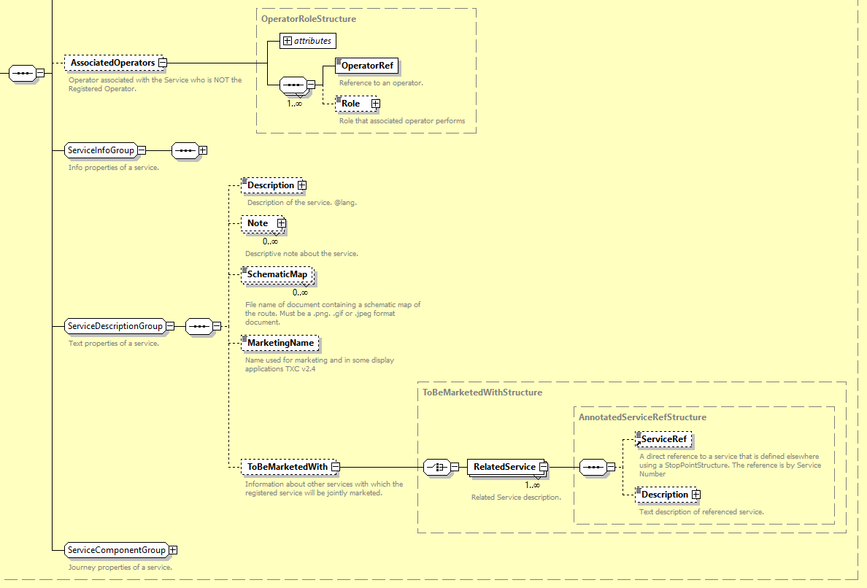
Figure 11 - Excerpt from Service element showing association elements

For example, the code snippet below shows a service which is related to one operated by the operator with a national operator code of “PQRS”, and specifically refers to a service with service code PH0001045:22. It is the responsibility of the downstream user to identify this service and to fetch the data for it.
<AssociatedOperators>
  - <OperatorRef>PQRS</OperatorRef>
</AssociatedOperators>
...
<ToBeMarketedWith>
  - <RelatedService>
    - <Description>PH0001045:22</Description>
  - </RelatedService>
</ToBeMarketedWith>

➲
In TXC-PTI, linked services from different operators may not appear in a single TXC document.
➲
In TXC-PTI, services which are operated by multiple operators may be linked using AssociatedOperators and ToBeMarketedWith. The OperatorRef shall be the NOC of the linked operator, and the Description for the RelatedService shall contain the ServiceCode of the linked service.
This mechanism may also be used to link different documents (services) from the same operator where there is a split registration.

    - Standard services
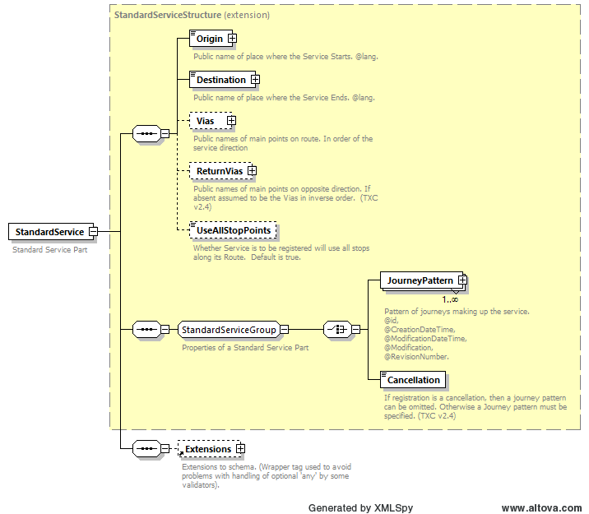
Figure 12 -The StandardService element
Within the Service element, TXC can describe the default operating pattern of the service, either as a standard service or as a flexible service. A standard service is one which follows a set of stops, in sequence, to a strict timetable, while a flexible service is one which may or may not follow a set of stops in sequence and operates flexibly as and when it is booked. It may therefore not run at all and may only run to some of the stops that are declared.
TXC-PTI is only concerned at present with standard services, however flexible services are discussed briefly in section 0 for future extensions of the profile.
In TXC-PTI, a StandardService element is required for standard, non-flexible services, because there needs to be at least one JourneyPattern defined and referenced in a VehicleJourney.This StandardService shall have elements as set out in the table below.

Table 11 - Permitted elements for StandardService
Element Name | Data Type | Used in TXC-PTI
Origin | NaturalLanguageString | Schema mandated.
Destination | NaturalLanguageString | Schema mandated.
Vias | ViasStructure | Where appropriate but avoid use where possible.
ReturnVias | ViasStructure | Where appropriate but avoid use where possible.
UseAllStopPoints | boolean | Not used
JourneyPattern | JourneyPatternStructure | Yes. Shall include at least one JourneyPattern. See 8.2
Cancellation | EmptyType | Not used (schema mandated to be omitted if JourneyPattern present)
Origin and Destination shall be included, as these are mandated by the schema.
Vias and ReturnVias are optional, however these are better completed for the individual lines and hence can largely be ignored for TXC-PTI.
The UseAllStopPoints flag is not to be used, as this is not public facing information and all the stopping points that the service uses should be encoded into the individual vehicle journeys via references to journey patterns.
The StandardService shall include one or more JourneyPattern elements sufficient to describe at least one pattern in each direction. For details of how a JourneyPattern is to be structured, refer to section 8.2 below.
➲
In TXC-PTI, a non-flexible service shall have a StandardService which shall consist of at least one JourneyPattern.
At least one JourneyPattern must be provided for a StandardService otherwise the validator will report an error.

    - Interchanges
      - Introduction
Interchanges in TXC can be problematic, because all of the trips that are required for interchange need to be in the same TXC document. This means that, in many cases and particularly for split registrations, it is not easy to describe the interchanges. Other methods of communicating this data have been therefore been developed, although these show some supplier variation and are not part of a standardised TXC exchange.
However, this does not mean that TXC is incapable of describing interchanges, or that TXC-PTI documents should not try to describe interchanges when all of the required information is already in the document. This is particularly true for circular and “pan-handle” services where the outbound trips merge seamlessly into the inbound trips (and/or vice versa) and where passengers can remain in the vehicle. Here, the relevant trips would all be in the same document, since this is a single line.
A secondary class of interchange of this type is where a line name changes to another line name using the same vehicle, and again passengers are allowed to remain on the vehicle, or where there is a guaranteed connection between two lines albeit that passengers have to change (e.g. the vehicles “kiss and turn”). These secondary usages are more limited in scope, because the two lines would require to be in the same document and that cannot be guaranteed.
However, wherever interchanges can be defined, it is recommended that a TXC-PTI document should provide this information using TXC’s JourneyPatternInterchange element.
➲
It is recommended that, in TXC-PTI, interchanges which can be made on the same service (including between different lines on the same service that are included in the same TXC-PTI document) should be included using JourneyPatternInterchange elements as described below.

The JourneyPatternInterchange element is the way that interchanges are described at a service level in a TXC file. This describes interchanges that can always be made, regardless of the trip operating. Where possible connections exist that vary from trip to trip (for example, only some journeys are through journeys) then this should be described by a VehicleJourneyInterchange instead (see section 9.6).
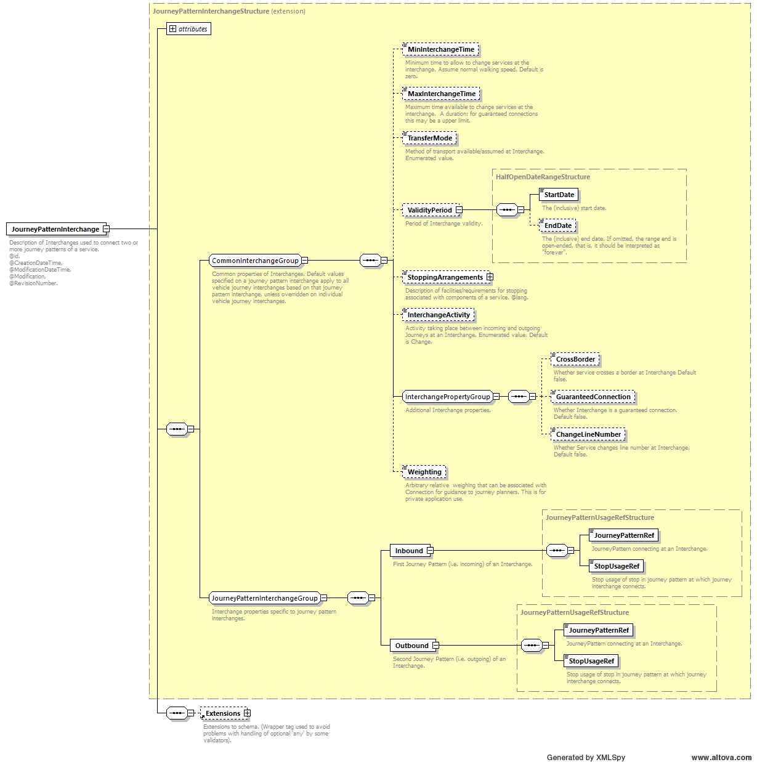
Figure 13 - The JourneyPatternInterchange element

A JourneyPatternInterchange is made up of two groups of elements. The first of these is the common interchange group, which is a set of elements that are common to both journey pattern interchanges and vehicle journey interchanges, and the second of these is the journey pattern interchange group, which is a set of elements that are particular to a journey pattern interchange.
Where a TXC-PTI document chooses to have default journey patterns with zero-minute link durations and actual times in vehicle journeys (see section 0), a JourneyPatternInterchange shall not be used and a VehicleJourneyInterchange shall be used instead. VehicleJourneyInterchange elements are described in section 9.4.

      - The common interchange group
The common interchange group consists of a number of elements, with permitted values in TXC-PTI as shown in Table 12 below.
Table 12 - Permitted elements in the common interchange group
Element Name |  | Data Type | Use in TXC-PTI
MinInterchangeTime |  | DurationType | The minimum permitted interchange time (default = 0 mins). Use where appropriate
MaxInterchangeTime |  | DurationType | The maximum time for a guaranteed connection. Use where appropriate.
TransferMode |  | AllModesEnumeration | Not used as assumed that the interchange mode is the mode of the service.
ValidityPeriod | StartDate | StartDateType | Not used as assumed that the interchange is valid for the duration of the OperatingPeriod.
ValidityPeriod | EndDate | EndDateType
StoppingArrangements |  | NaturalLanguageString | Not used.
InterchangeActivity |  | InterchangeActivity  Enumeration | Mandated in TXC-PTI interchanges. Describes the interchange as follows:  transferOnly not used.  change used for change of vehicle.  through used to stay on vehicle.  split not used.  join not used.
CrossBorder |  | boolean | Optional.
GuaranteedConnection |  | boolean | Mandated in TXC-PTI interchanges. Set to true for a guaranteed connection which require changes of vehicle, or for through connections with the same line name. False otherwise.
ChangeLineNumber |  | boolean | Mandated in TXC-PTI interchanges. Set to true where a through connection changes line name. False otherwise.
Weighting |  | integer | Optional.

The valid InterchangeActivity enumerations for BODS are change and through only.

      - The journey pattern interchange group
The specific details of the journey pattern interchange are defined within the journey pattern interchange group. There are two elements, Inbound and Outbound, both of which are mandated by the schema. Each of these is constructed similarly, in that there is a reference to a journey pattern (JourneyPatternRef), and the NaPTAN reference (Atcocode) for the stop point at which the interchange takes place in that journey pattern (StopUsageRef). Both JourneyPatternRef and StopUsageRef are mandatory in the schema.
Inbound shall be used for the feeder (incoming) journey pattern, and Outbound shall be used for the distributor (outgoing) journey pattern. Note that the terminology here is slightly confusing, in that inbound and outbound refer to trips incoming and outgoing from the interchange point and do not necessarily match with the inbound and outbound direction of the trip within the line/service.

      - Examples of a journey pattern interchange
The following examples show how an interchange might be defined at a service level for First in Leicester lines 16, a “pan handle” service, and 17, a circular.
The pan handle line 16 has connections between two different journey patterns in different directions (although reference would need to be made to the journey patterns in question to confirm that this was actually the case). The connection is made at Atcocode 269039050, and for a panhandle service it is clear that this needs to be the same stop on the feeder as the distributor.

<JourneyPatternInterchange>
  - <MinInterchangeTime>PT0M</MinInterchangeTime>
  - <InterchangeActivity>through</InterchangeActivity>
  - <GuaranteedConnection>true</GuaranteedConnection>
  - <Inbound>
    - <JourneyPatternRef>JP_12-16-_-y08-1-1-H-1</JourneyPatternRef>
    - <StopUsageRef>269039050</StopUsageRef>
  - </Inbound>
  - <Outbound>
    - <JourneyPatternRef>JP_12-16-_-y08-1-5-R-2</JourneyPatternRef>
    - <StopUsageRef>269039050</StopUsageRef>
  - </Outbound>
</JourneyPatternInterchange>

The circular line 17 has connections between the same journey pattern in the same direction (although again this is not clear without reference back to the journey pattern definitions). As can be seen, it is identical in construction to the pan handle interchange.

<JourneyPatternInterchange>
  - <MinInterchangeTime>PT0M</MinInterchangeTime>
  - <InterchangeActivity>through</InterchangeActivity>
  - <GuaranteedConnection>true</GuaranteedConnection>
  - <Inbound>
    - <JourneyPatternRef>JP_12-17-_-y08-1-1-H-1</JourneyPatternRef>
    - <StopUsageRef>269057024</StopUsageRef>
  - </Inbound>
  - <Outbound>
    - <JourneyPatternRef>JP_12-17-_-y08-1-1-H-1</JourneyPatternRef>
    - <StopUsageRef>269057024</StopUsageRef>
  - </Outbound>
</JourneyPatternInterchange>

As routes (short workings, etc.), timings, and hence journey patterns, can change across the course of the day, or days of the week, there will of necessity be a number of different combinations of interchanges to suit the differing journey pattern combinations.

    - Other elements
Other elements in Service shall be populated as shown below. Refer back to Table 8 to see their place in the overall Service element and confirmation of their usage.
- RegisteredOperatorRef shall be populated, as per the schema, with the (internal) reference of the operator defined in the Operator block.
- Where a particular vehicle type with the same set of accessibility features, is commonly used on all trips, VehicleType may be populated at Service level. This can then be omitted in all VehicleJourney elements except those where it is known to be different. Where included, VehicleType shall be populated as set out in 0 above. As indicated therein, this only indicates the intent of the operator, and is not a guarantee of any particular vehicle actually operating the service as this may change for operational reasons at very short notice.
- Mode shall be populated at Service level on the same basis.
- PublicUse shall be included and shall state explicitly whether a service is available to the public (true) or whether it is a closed service (false). This allows school services, etc. which are closed to nevertheless be entered into data, and hence allow trips to school to be planned for students. This flag shall be in place of the SchoolOrWorks designation, part of the ServiceClassification. ServiceClassification is related to registrations and is not public-facing, and hence shall not be used within a TXC-PTI document.
Note that a service may be open to the public but have restricted boarding / alighting. For example, the last stop on a public service may be within school grounds first thing in the morning, and only students would be allowed to use it. This restriction is derived from NaPTAN, where a stop may be flagged as private, and users need to reflect both the nature of the service and the nature of the stops when presenting information to the public.
- CommercialBasis is a flag that denotes whether or not the service is operated commercially (notContracted) or whether it is wholly or partially contracted (contracted, partContracted). While this is of limited use to the public, contracting authorities are keen to demonstrate their role in providing socially necessary services. Hence this flag is optional, but may be provided at Service level if required. At this level, it denotes that all trips have this commercial basis unless indicated otherwise.
- One or more Note elements may be provided, where appropriate. As far as possible, however, all information that is in a note which is encodable as data within a TXC-PTI document should be so encoded. Notes shall be as described in section 2.5.
- MarketingName may be included where appropriate. Where a name is simply a long service name, this shall be included in the Line element instead. For example, Trent Barton’s “black cat” service shall be given that LineName. However, the First Norfolk & Suffolk “excel” is a marketing name for a group of lines with names “A”, “B”, “C”, etc.
- PrivateCode is optional and may be populated if required by legacy systems.
All other elements not explicitly discussed above shall be omitted in a TXC-PTI document. In particular, this includes the Description and Direction elements:
- Description element was intended to replicate the description box on a registration document, where an operator would describe the change to the service in this registration e.g. “Re-timed journeys in the morning to improve reliability”. As TXC has become more widespread, this has often been repurposed to give an overall description of the service e.g. “Hereford – Worcester via Ledbury and Great Malvern”. This, though, is unidirectional and there are better ways of achieving the same end as described in 5.5.4 below.
- Direction is intended to define the default direction of the service. However, this can lead to confusion and in TXC-PTI the direction will be stated explicitly on each journey patterns.
➲
In TXC-PTI, VehicleType, Mode, Note, MarketingName, PrivateCode and CommercialBasis may be included where appropriate. Where they are, they shall be structured as set out above.
➲
In TXC-PTI, RegisteredOperatorRef and PublicUse shall be populated. With the exception of the optional elements listed above and those described in earlier sections, no other elements within Service shall be populated (see Table 8).

  - The Lines group
The Lines group in TXC is a grouping element within a Service that can hold one or multiple line records. As noted above a service may consist of one or more related lines, and consequently a Lines group in TXC-PTI may also hold one or multiple line records.
As well as the use case outlined in 5.1 above, an operator may also operate two distinct patterns of operation which are seasonal in nature, i.e. a summer and winter timetable. Where these do not vary from year to year, the operator would not wish to continually update the data to swap between the two and would wish instead to have both patterns within the same TXC-PTI document.
This type of arrangement could very easily be handled through individual dated VehicleJourney records. However, this doesn’t give a clear separation of the timetables and analysis of the individual records would need to be carried out to understand how to present the “summer” and “winter” timetables to the public.
For these situations, then, it is preferable to have the two patterns coded as distinct lines, albeit sharing the same LineName, within TXC-PTI. It is then clear through the referencing which pattern is which, and which trips belong with which pattern.
➲
For TXC-PTI, a Lines group may contain multiple Line elements, so long as the lines are related either spatially (e.g. 1/1A) or temporally (e.g. summer & winter timetables on line 1).
Where multiple Line elements are provided then each Line must have at least two StopPoints in common with other lines in the same TransXChange file.

  - The Line element

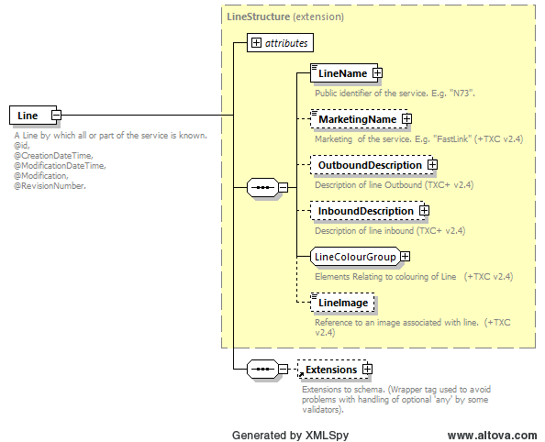
Figure 14 - The Line element

    - Introduction
The Line element in TXC describes one of the lines that comprise the service, provides a unique identity for the line, and describes how the line shall be known to the public. It also specifies the separate inbound and outbound descriptions of the service, e.g. outbound as “Hereford to Worcester via Ledbury and Great Malvern”, inbound as “Worcester to Hereford via Great Malvern and Ledbury”.
As stated earlier, there may be multiple Line records in a single TXC-PTI document. However, there shall only ever be one version of a given line in a single document. This is true even for seasonal timetables – the two lines represent a single version which encompasses two distinct operating patterns.
A Line shall be versioned, as described in 2.3 above.
Mandatory, optional and unused elements within a Line are as shown in the table below. Detailed usage of the elements is described more fully in the sections which follow.

Table 13 - Permitted elements for Line
Element Name | Data Type | Used in TXC-PTI
LineName | NaturalLanguageString | Mandatory in schema. See this section.
MarketingName | NaturalLanguageString | Where appropriate. See 5.5.3
OutboundDescription | LineDescriptionStructure | Where appropriate, although must have one of OutboundDescription or InboundDescription. See 5.5.4
InboundDescription | LineDescriptionStructure | Where appropriate, although must have one of OutboundDescription or InboundDescription. See 5.5.4
LineColour | ColourValueType | Where appropriate.
LineFontColour | ColourValueType | Optional
AlternativeLineColour | ColourValueType | Optional
AlternativeLineFontColour | ColourValueType | Optional
LineImage | anyURI | Optional

    - Identifying the line
The id attribute of the Line element uniquely identifies the line. For TXC-PTI this shall take the form of a number of different components, separated by colons, as follows:
- The most granular NOC for the operator (e.g. FESX for First Group’s bus operations in Essex);
- The ServiceCode (to assist in linking to other lines in the same group of lines); and
- The line name.
For the avoidance of doubt, the line id shall not include a version number. Version control shall be in accordance with 2.3 above.
For example, two distinct line 8s operated by First in Essex might appear (in separate TXC-PTI documents, within their own individual Service elements) as:
<Service RevisionNumber="1">
  - <ServiceCode>PF0000599:41</ServiceCode>
  - <Lines>
    - <Line id="FESX:PF0000599:41:8">
      - <LineName>8</LineName>
    - </Line>
  - <Lines>
  - ...
  - <RegisteredOperatorRef>FESX</RegisteredOperatorRef>
  - ...
</Services>
and
<Service RevisionNumber="4">
  - <ServiceCode>PF0000599:75</ServiceCode>
  - <Lines>
    - <Line id="FESX:PF0000599:75:8">
      - <LineName>8</LineName>
    - </Line>
  - <Lines>
  - ...
  - <RegisteredOperatorRef>FESX</RegisteredOperatorRef>
  - ...
</Services>

Where a service contains two lines which are the seasonal variants of the same service, this can be indicated by the addition of an additional seasonal identifier at the end of the line id. This should be separated from the rest of the id by a colon.
For example, if the service 8 in the example above had summer and winter timetables, then these could be identified as follows:

<Service RevisionNumber="4">
  - <ServiceCode>PF0000599:75</ServiceCode>
  - <Lines>
    - <Line id="FESX:PF0000599:75:8:winter">
      - <LineName>8</LineName>
    - </Line>
    - <Line id=" FESX:PF0000599:75:8:summer">
      - <LineName>8</LineName>
    - </Line>
  - <Lines>
  - ...
  - <RegisteredOperatorRef>FESX</RegisteredOperatorRef>
  - ...
</Services>

Note that some services may consist of lines that operate all year round, with additional summer trips on a different line number. In this case it is acceptable in TXC-PTI to place the seasonal identifier on the end of the seasonal line id, even though there is no corresponding winter timetable.
Note also that such timetables will, in any event, need to be refreshed at least once a year in order to put the correct dates of operation for that year into the service.
Seasonal timetables are the only instance in TXC-PTI where a line may be split. It is not permitted, for example, to have separate TXC-PTI lines or documents for e.g. Mondays to Fridays, Saturdays, etc. operations.
➲
In TXC-PTI, the line id shall follow a consistent format of the NOC, the ServiceCode, the line name, and, if appropriate, the seasonal identifier, separated by colons. It shall not include a version number.

    - Line name, line colour and marketing name
The LineName element is mandatory and shall contain the public-facing name of the service, in full. For example, Trent Barton’s “indigo” service shall have a LineName of “indigo”, and not any shortened version of it (e.g. “IGO”).
The LineColour element is optional and shall be included when a line has a preferred colour to use when showing line in graphic media.
The MarketingName is optional and shall be included where a line has a marketing name that is different to other lines within the service. Otherwise, MarketingName shall be omitted and any marketing name included at the Service level.

    - Describing the line
In a TXC-PTI document, the line shall have a description for each direction of the line that describes the overall route of the line in general terms. It does not have to describe every place served but should be sufficient to identify the line in public-facing publicity.
This is achieved by use of a line’s OutboundDescription and InboundDescription elements. Both of these are constructed the same way, using a LineDescriptionStructure as shown below:

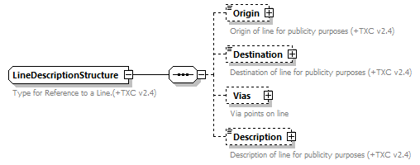
Figure 15 - The line description structure
These elements shall be completed as per the table below.

Table 14 - Permitted elements in a LineDescriptionStructure
Element Name | Data Type | Used in TXC-PTI
Origin | NaturalLanguageString | Where appropriate
Destination | NaturalLanguageString | Where appropriate
Vias |  | Where appropriate but avoid use where possible..
Description | NaturalLanguageString | Yes. Shall be included

This structure allows the description to be specified granularly, using Origin, Destination, and a set of some or all of the Vias (listed in order of calling), and these elements can be populated in TXC-PTI if required. The Description field, however, is mandatory and shall contain a pre-formatted textual description of the inbound and outbound directions. The earlier example showed, for instance, that a line might be described as “Hereford to Worcester via Ledbury and Great Malvern” outbound, and as “Worcester to Hereford via Great Malvern and Ledbury” inbound.
Some general points to note, for TXC-PTI:
- For each direction of the line, there shall be a corresponding description.
- If any direction is not present in the line, the corresponding description shall be omitted.
- There are additional directions that are possible for a line, including clockwise and anti-clockwise. For the purposed of TXC-PTI, the OutboundDescription shall be used for clockwise directions, and the InboundDescription shall be used for anti-clockwise directions.
➲
In TXC-PTI, each direction of a line shall have a matching description element that describes the route of that particular line in that direction. Clockwise and anti-clockwise services are mapped to outbound and inbound description elements respectively.
The validator requires OutboundDescription to be provided unless InboundDescription is provided and vice versa.

- Stop points and stop areas
  - Introduction
In a TXC document, stop point declarations are required so that they can be referenced, ultimately, in the individual vehicle journeys. There are two ways provided in TXC for doing this:
- by referencing a stop already in NaPTAN; or
- by creating a new stop record in the same format as a stop record in NaPTAN.
In addition, TXC allows the creation of NaPTAN “stop areas” to replace or supplement those in NaPTAN.

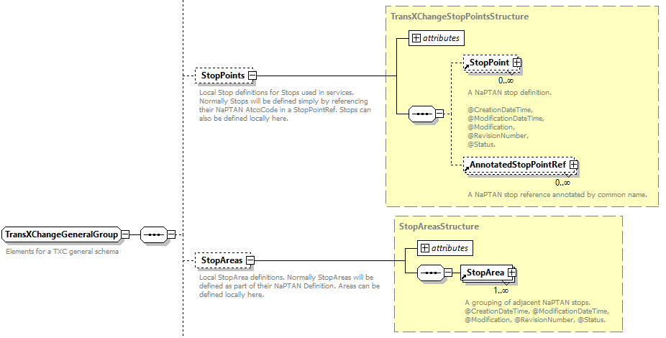
Figure 16 - StopPoints and StopAreas in a TXC document

Stop data (including for StopAreas) is maintained in NaPTAN as the primary source, and the TXC-PTI document shall always prefer to use a reference to a NaPTAN stop record; the creation of new stop records shall be reserved for the very specific cases set out below and shall be replaced by a NaPTAN reference as soon as one exists. Additionally, as stop areas are maintained in NaPTAN, StopAreas shall be omitted in TXC-PTI.

In TXC-PTI, StopPoints shall use AnnotatedStopPointRef elements to refer back to NaPTAN unless this is not possible. StopPoint shall be used sparingly and only for specific use-cases. StopAreas shall be omitted.
➲
The use of StopPoint is allowed for a maximum period of 2 months. This is validated by ensuring the RouteLink referencing the StopPoint is not used by one or more VehicleJourney for more than 2 months by checking start and dates of the OperatingProfile for the VehicleJourney.

  - Stop points referencing NaPTAN
As already indicated, TXC-PTI shall as far as possible reference an existing NaPTAN stop, using an AnnotatedStopPointRef, which has the structure shown in the figure below.
The permitted elements are as follows:

Table 15 - Permitted usage of AnnotatedStopPointRef elements
Element Name | Data Type | Used in TXC-PTI
StopPointRef | StopPointCodeType | Mandated by schema
CommonName | NaturalLanguageString | Mandated by schema
Crossing | NaturalLanguagePlaceName | Not used – read from NaPTAN
Street | NaturalLanguagePlaceName | Not used – read from NaPTAN
Indicator | NaturalLanguagePlaceName | Where appropriate to aid readability
StopType | StopTypeEnumeration | Not used – read from NaPTAN
BusStopType | BusStopTypeEnumeration | Not used – read from NaPTAN
LocalityName | NaturalLanguageString | Where appropriate to aid readability
LocalityQualifier | NaturalLanguageString | Where appropriate to aid readability
Location | LocationStructure | Not used – read from NaPTAN

Of the elements that are included within the AnnotatedStopPointRef, only two are required by the schema: StopPointRef, which is the actual NaPTAN reference (Atcocode) of the NaPTAN stop; and CommonName, which is intended to be a re-statement of the name of the stop in NaPTAN in order to aid readability and diagnostics in a TXC file. Other optional elements, which were extended in TXC v2.4, contain more of the information from the NaPTAN file.

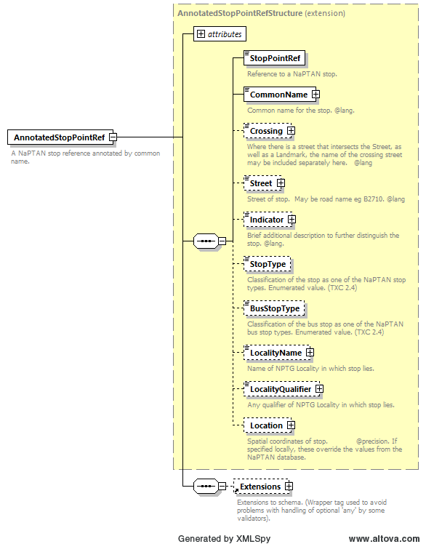
Figure 17 - The AnnotatedStopPointRef element
At no point was it intended that the elements populated in an AnnotatedStopPointRef structure should replace or overwrite the contents of NaPTAN.
This intent is continued, and made explicit, in TXC-PTI. StopPointRef is essential, and CommonName is mandated by the schema, so both shall be present in a TXC-PTI document.
Additionally, to aid readability, Indicator, LocalityName and LocalityQualifier may be included in a TXC-PTI document. Other elements shall be omitted and taken from NaPTAN.
In general, where a stop point field in TXC-PTI is different to NaPTAN, then the details held in NaPTAN shall be used in preference. If the naming in NaPTAN is deficient then the naming in NaPTAN should be discussed with the stop owner and agreement reached as to the accepted name.
Note that NaPTAN is a granular schema, with the different parts of the naming broken down into different fields. This allows users to compose stop names that suit their purposes from the different fields, which may be different depending on usage. For example, an express service between two towns, which only calls once in each locality, may well refer to the stop by just the locality name; conversely, a service which runs solely in one of those towns may well call the same stop by its common name only, and omit the locality completely. This is up to the end user, and data should not be overwritten simply to accommodate one use-case.
Any stop point that is used shall be appropriate to the service being described. For example, a bus service shall use only bus stops (either on-street or in bus stations) and shall not use rail station or ferry terminal stops, taxi ranks, etc. Likewise, where a TXC-PTI document is being used for other modes, those modes shall also use appropriate stops – metro service shall use metro stops, etc.

In TXC-PTI, an AnnotatedStopPointRef shall be used to refer to an appropriate NaPTAN stop. It shall contain a StopPointRef and a CommonName, and may optionally include an Indicator, a LocalityName and a LocalityQualifier. It shall not have other elements.
➲

  - Stop points not referencing NaPTAN
As indicated earlier, there will be occasions where an operator needs to refer to a stop that is not yet in NaPTAN, or which has no real need to be in NaPTAN e.g. temporary stops for festivals, etc. In such cases, which will be set out in legislation and guidance, an operator may declare a new stop using a StopPoint element. This element embeds the NaPTAN schema, and so it shall be populated according to the rules set out in NaPTAN. The detail of this is outside of the scope of this document, and users should refer to the NaPTAN schema guidance document.

- Routes and tracks
  - Introduction
In TXC, a Route, together with its constituent RouteSections and RouteLinks, describes the physical sequence of stopping points served. At its most basic it is a series of NaPTAN stop points and nothing more, which therefore provides a routing which is independent of any particular coordinate system. A particular route can be projected onto the underlying road network through the use of the Tracks. The following diagram from a route in Exeter serves to illustrate this:
Figure 18 – Example of routes and tracks showing different levels
It is important to note that, within a TXC document, a route does not have any timing information associated with it. It is simply a series of stops which may be described in geographic terms by the addition of geographic points in a track. Because of this, and because a journey pattern restates the links that occur, a Route is an optional element in TXC, and several systems omit it.
Omitting track information, however, is limiting when the data will be used to drive real-time systems; prediction engines work best if they understand the route distance between stops as accurately as possible. Without track information, such systems will only be able to use “crow flies” distances between stops derived from stop coordinates in NaPTAN, or they will have to add information or estimate the tracks themselves. This is clearly undesirable, and hence Route, RouteSection, and RouteLink elements are mandated in TXC-PTI documents, with Track elements being strongly recommended.
These elements shall be populated in accordance with the TXC schema. Element ids can be constructed to suit the originating system, and there are no specific rules for TXC-PTI except that:
- The RouteLink/Distance element may be populated as an intermediate stage between no track and full track, although is shall be populated with an accurate measurement of the travelled distance between the two stops.
- The RouteLink/Direction element shall not be populated, in order to facilitate re-use of definitions between different routes without potential conflicting directions.
Additionally, a tendency in TXC is to export entire routes as single route sections, which then repeat sequences of stops when there are variations to routes e.g. short workings. It is strongly recommended that a TXC-PTI document uses efficiency when creating RouteSections, breaking them down into logical sections, so that re-use within Routes is readily achievable. This will help limit file sizes.
It is noted that operators submitting EBSR documents are required to provide tracks which have at least one point on every individual street that the vehicle travels down, in sequence. Where such information exists then this minimum information shall be used to populate a Track, although operators should strive to get full routing information into TXC-PTI as soon as practical.
➲
In TXC-PTI, Route, RouteSection, and RouteLink elements shall be provided. It is strongly recommended that RouteSections are logically structured to facilitate re-use within Routes to help minimise file sizes.
➲
In TXC-PTI, Track elements are strongly recommended. Where possible, operators should populate these with, at a minimum, the single point on each street as per the EBSR requirements.
The validator checks the RouteLink elements to ensure that no two RouteLinks are identical.

  - Routes
A Route element is mandated for TXC-PTI, as set out in the introduction to this section above. It’s structure is as shown in Figure 19 below, and it shall use the elements as set out in .

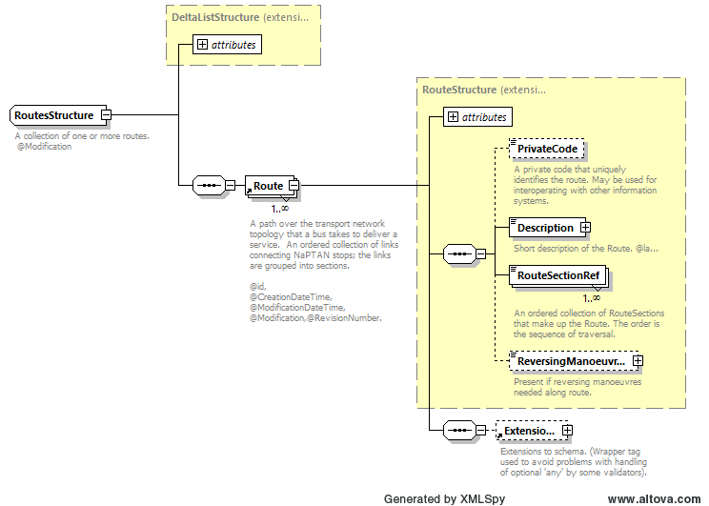
Figure 19 - The Routes structure
Table 16 - Usage of Route elements
Element Name | Data Type | Used in TXC-PTI
PrivateCode | PrivateCodeType | Where appropriate
Description | NaturalLanguageString | Mandated by schema
RouteSectionRef | RouteSectionIfType | References to an ordered list of RouteSections. Mandated by schema
ReversingManoeuvres | NaturalLanguageString | Not to be used
➲
In TXC-PTI, a Route element shall be provided containing a Description and an ordered list of RouteSectionRefs. It may also contain a PrivateCode for compatibility with other systems if required. It shall not contain a ReversingManoeuvres element.
The validator checks to ensure that ReversingManoeuvres is not provided.

  - RouteSections and RouteLinks
At least one RouteSection element is mandated for TXC-PTI, as described in the introduction, and this in turn mandates at least one RouteLink within each RouteSectionl, although an ordered sequence of RouteLink elements is more usual. The structure of RouteLink is shown in the diagram below, with the permitted usages of elements shown in Table 17.

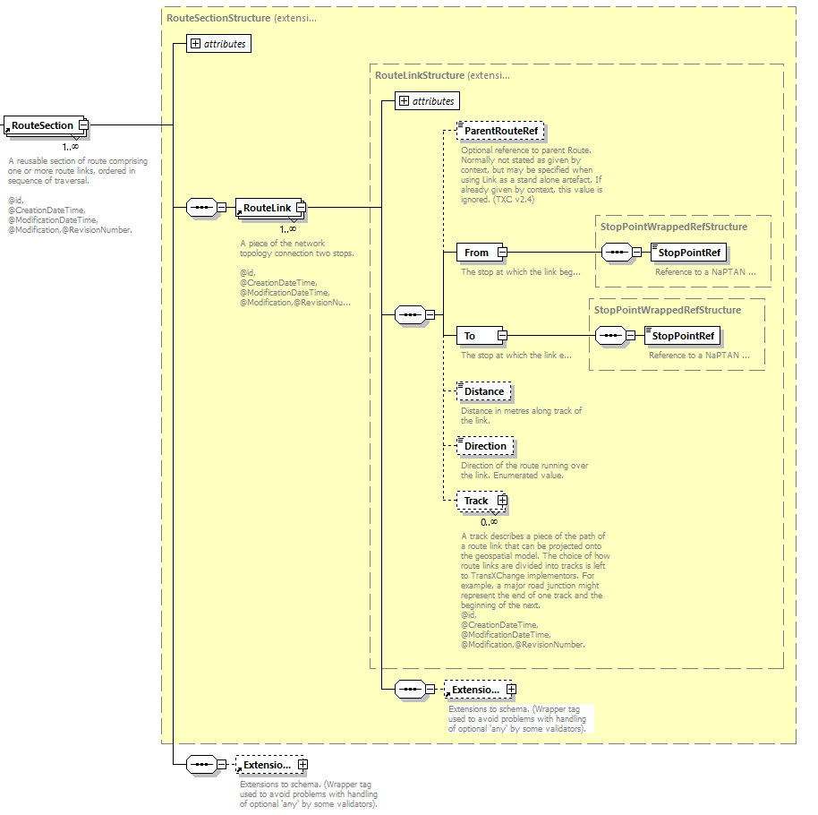
Figure 20 - RouteSection and RouteLink structure

Table 17 - Permitted usage of RouteLink elements
Element Name | Data Type | Used in TXC-PTI
ParentRouteRef | RouteRefStructure | Not used
From/StopPointRef | StopPointRefStructure | Mandated by schema
To/StopPointRef | StopPointRefStructure | Mandated by schema
Distance | DistanceType | Where appropriate
Direction | LinkDirectionEnumeration | Not to be used
Track | TrackStructure | Where appropriate. See 7.4
➲
In TXC-PTI, RouteSection, and RouteLinks elements shall be provided. Each RouteLink shall contain “from” and “to” stop point references, and may contain a link Distance if appropriate. Link Direction is not to be used.
➲
In TXC-PTI, Track elements are strongly recommended. Where possible, operators should populate these with, at a minimum, the single point on each street as per the EBSR requirements.
The validator checks to ensure that Direction is not provided.

  - Tracks
As already stated, there are very good reasons why a Track should be included in a TXC-PTI file. The track is an ordered set of coordinates that define the route that the vehicle takes between any given pair of stops. The structure of a Track is shown in the diagram below and, while it looks complicated, in practice it is not.

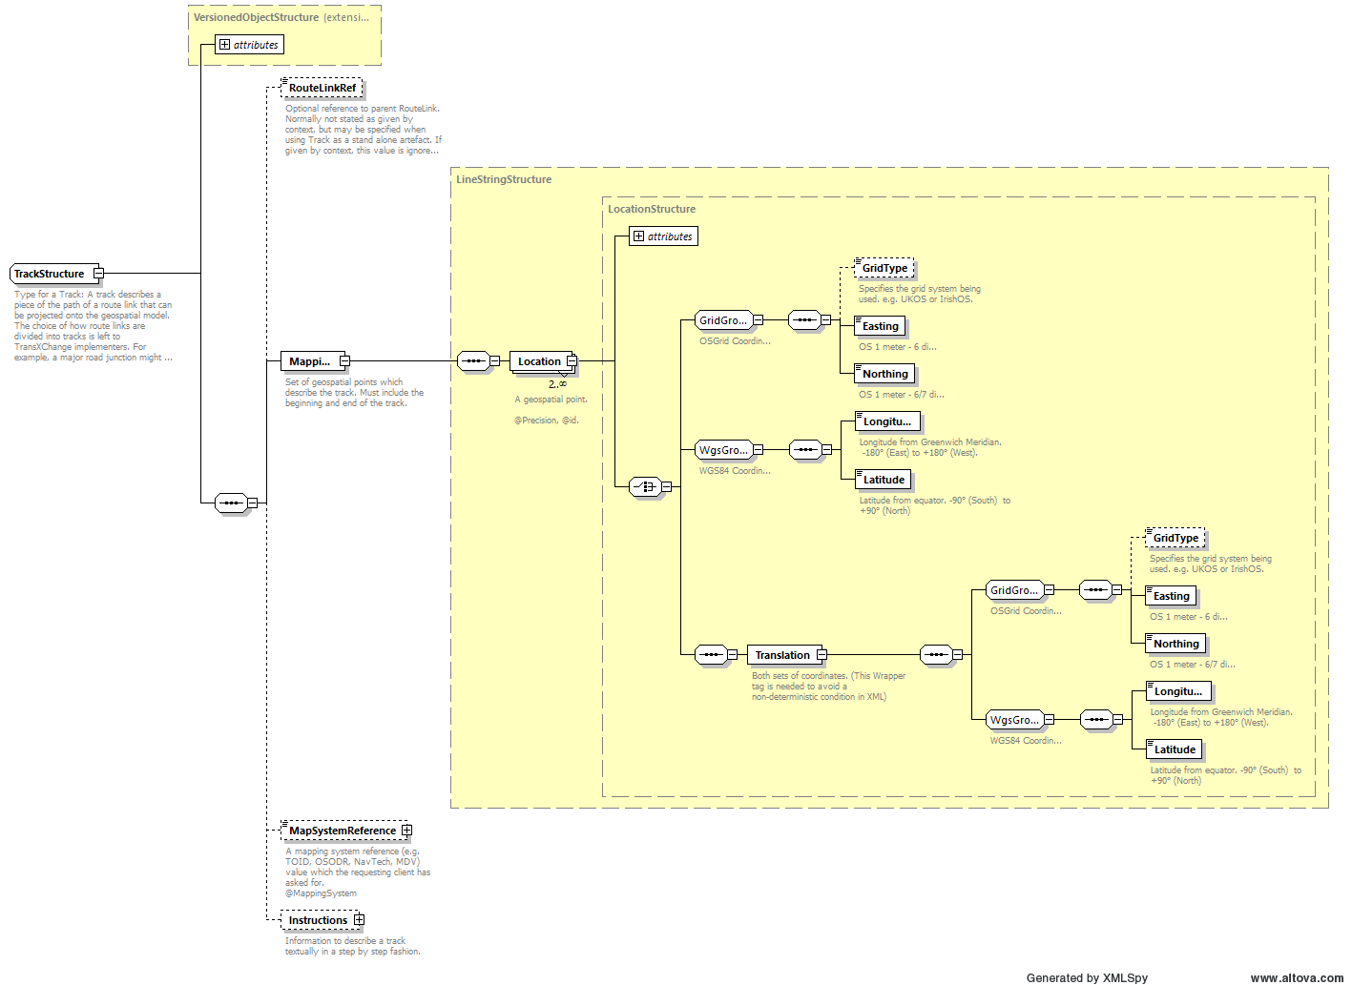
Figure 21 - The Track structure
In essence, the diagram is showing that a Track can consist of either an X-Y grid reference (usually OSGR for the UK, although IrishOS is also permitted), or a lat-lon reference (using the WGS84 datum), or a Translation element which allows both types of reference to be specified at the same time. This latter is more useful to end users, as they can then work in their preferred coordinate system without requiring further translation of coordinates, and is therefore preferred in TXC-PTI. This may be beyond the scope of many users generating the data, however, so this is a strong recommendation rather than being mandatory.

Where a Track is provided, the usage of elements in TXC-PTI is as shown in the table below.

Table 18 - Permitted usage of Track elements
Element Name |  |  |  | Data Type | Used in TXC-PTI
RouteLinkRef |  |  |  | RouteLinkRefStructure | Not used – set by context
Mapping |  |  |  | LineStringStructure | Mandated by schema
 | Location |  |  | LocationStructure | Mandated by schema. At least two Location elements required (one for each point on the track).
 | (Grid) | GridType |  | LocationGridTypeEnumeration | Set to OSGR for clarity
 | (Grid) | Easting |  | EastingType | Mandated by schema
 | (Grid) | Northing |  | NorthingType | Mandated by schema
 | (or WGS) | Longitude |  | LongitudeType | Mandated by schema
 | (or WGS) | Latitude |  | LatitudeType | Mandated by schema
 | (or both) | Translation |  |  | Preferred option in TXC-PTI
 | (or both) | (all) | GridType | LocationGridTypeEnumeration | Set to OSGR for clarity
 | (or both) | (all) | Easting | EastingType | Mandated by schema
 | (or both) | (all) | Northing | NorthingType | Mandated by schema
 | (or both) | (all) | Longitude | LongitudeType | Mandated by schema
 | (or both) | (all) | Latitude | LatitudeType | Mandated by schema
MapSystemReference |  |  |  | MapSystemReferenceStructure | Optional
Instructions |  |  |  | TrackInstructionsStructure | Optional
➲
In TXC-PTI, a single Track (if included) shall contain sufficient Location elements to define the route that the vehicle takes between a pair of stops.
➲
In TXC-PTI, use of Translation to allow both OSGR and WGS84 coordinates to be defined is strongly recommended, but not mandatory. Users can provide coordinates in their preferred coordinate system only, if required.

Track data if provided is checked to ensure that it includes at least two Location elements.

- Journey timings on standard services
  - Introduction
Journey timings in TXC are handled through JourneyPatterns, JourneyPatternSections and JourneyPatternTimingLinks. These relate structurally to the non-timed equivalents Routes, RouteSections and RouteLinks. TXC permits a JourneyPattern to operate over a shortened version of the Route that it maps onto, but for TXC-PTI this is not recommended and a JourneyPattern (and its sub-elements) shall have direct one-to-one mapping to the underlying Route (and its sub-elements).
As with routes, there has been a tendency in TXC to generate journey patterns which consist of a single journey pattern section with all of the timing links required for that particular journey pattern. Like routes, this leads to a significant increase in the file size since there is a high degree of redundancy. Therefore, TXC-PTI recommends that JourneyPatterns, like Routes, shall be structured efficiently so that sectional re-use is facilitated. This requirement in any case derives from the requirement to map journey patterns onto routes with a one-to-one mapping.
➲
In TXC-PTI there shall be at least one JourneyPattern for each direction, that a service operates, of a non-flexible service (StandardService – see section 0), and this (and its sub-elements) shall have a one-to-one mapping to a Route (and its sub-elements).
➲
In TXC-PTI it is strongly recommended that JourneyPatternSections are logically structured to facilitate re-use within JourneyPatterns to help minimise file sizes.

Note that TXC is a link-based schema. That means that a vehicle journey states the departure time of the trip, but that thereafter there is a duration over each successive link. This avoids problems where times can occur out of sequence in call-time based systems, but does mean that the actual call times at each stop need to be calculated by the consuming system by summing the link durations and any wait times up to that point and adding this to the departure time.
In TXC, there are two common ways of populating JourneyPatternSections (and the JourneyPatternTimingLinks that they contain):
- There is a JourneyPattern, JourneyPatternSection and JourneyPatternTimingLink set for every different combination of link duration, wait time and stop activities, with each piece of information explicitly written in. Individual vehicle journeys reference the appropriate journey pattern; and
- There is a single JourneyPattern, JourneyPatternSection and JourneyPatternTimingLink set for each direction, with each link duration and wait time set to zero minutes. This method uses the facilities in the vehicle journey to override the default zero-minute durations for each of the links. Stop activity, however, is usually included in the JourneyPatternTimingLink in the same way as method (1).
TXC-PTI will accept either way of defining the timings, so long as:
- only one method is used, not a mix of methods; and
- all run times and wait times in JourneyPatternTimingLinks in method 2 are set to zero minutes duration, and all vehicle journeys explicitly state the duration and wait time for each link.
For the avoidance of doubt, TXC-PTI permits the definition of the stop activity within the JourneyPatternTimingLink, as set out below, which shall be inherited by the vehicle journeys even when link durations are being overridden.

In TXC-PTI, either sufficient JourneyPatternSection elements shall exist to fully define the different timing and activities of a service, with all values explicitly stated, or there shall be a minimum of JourneyPatternSection elements where all of the durations and wait times are set to zero.
➲
To check that only only one method of defining timings is being used if a JourneyPatternSection has non-zero times then the vehicle journey should not include link times. If this is not the case then the validator will raise an error.

  - The JourneyPattern element
A JourneyPattern element is constructed using a JourneyPatternStructure, as shown below.
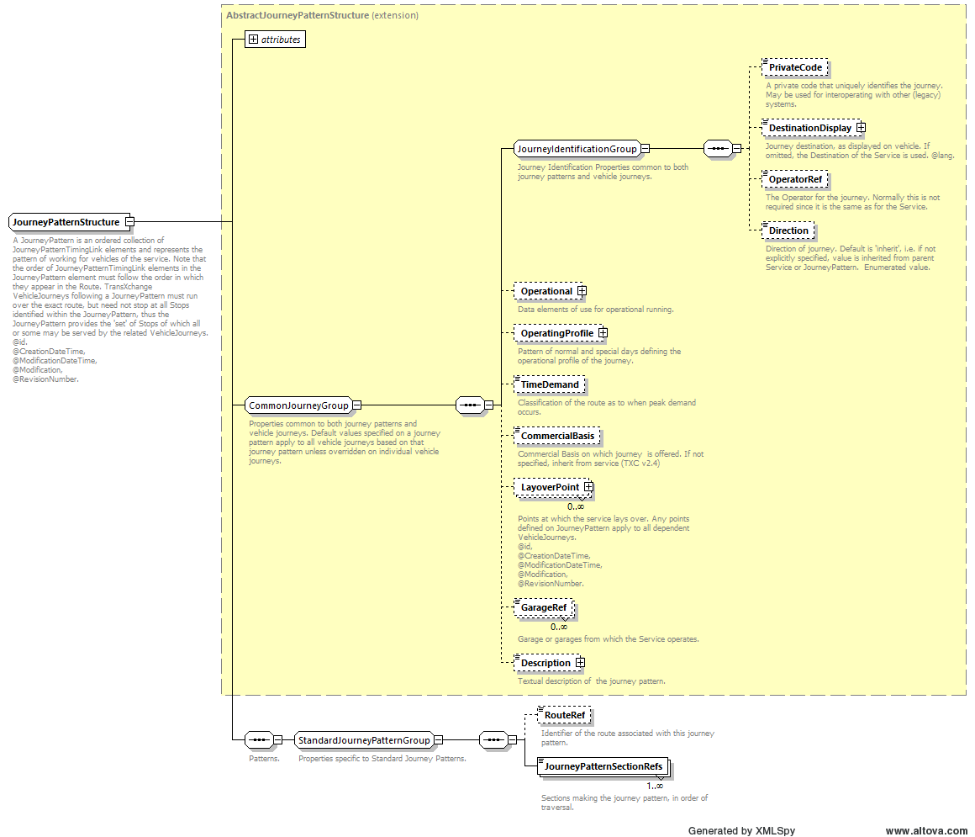
Figure 22 - The JourneyPattern structure

These elements shall be populated according to the table below.

Table 19 - Permitted elements for JourneyPattern
Element Name | Data Type | Used in TXC-PTI
PrivateCode | PrivateCodeType | Where appropriate
DestinationDisplay | NaturalLanguageString | Yes, shall be provided if not using DynamicDestinationDisplay.
OperatorRef | OperatorRefStructure | Yes, shall be included. Reference to defined Operator
Direction | JourneyPatternVehicleDirection  Enumeration | Yes, shall be included.
Operational | OperationalStructure | Not used at this level. Use within Service instead. See section 5.3.3.
OperatingProfile | OperatingProfileStructure | Not used at this level. Use within Service or VehicleJourney. See sections 5.3.3 and 9.3
TimeDemand | TimeDemandEnumeration | Not used at this level.
CommercialBasis | JourneyCommercialBasisEnumeration | Not used at this level. Use within Service or VehicleJourney. See sections 5.3.3 and 9.2
LayoverPoint | LayoverPointStructure | May be included to aid in real time information. See section 9.7.2
GarageRef | GarageRefStructure | Not used at this level
Description | NaturalLanguageString | Optional
RouteRef | RouteRefStructure | Yes, shall be included. Reference to a defined Route
JourneyPatternSectionRefs | JourneyPatternSectionRefStructure | Yes, shall be included (at least one)

A PrivateCode may be included for compatibility with legacy systems.
A DestinationDisplay element shall be provided unless a DynamicDestinationDisplay is provided for all stops in the JourneyPatternTimingLink. This allows systems to state the ultimate destination of the journey.
An OperatorRef shall be included and shall reference the id of the (single) Operator element.
Direction shall be included at the JourneyPattern level. It shall then be assumed that all RouteSections and RouteLinks are in the same direction. This allows re-use without confusion of, for example, route sections describing a route through a town centre which is used in multiple directions.
Operational, OperatingProfile and CommercialBasis elements shall not be provided at the JourneyPattern level. These are best placed within individual vehicle journeys. An OperatingProfile default and a CommercialBasis default may additionally be provided at the Service level.
A RouteRef shall be provided to link the journey pattern to the corresponding route.
A series of JourneyPatternSectionRefs shall be provided, referencing the sequence of journey pattern sections that together make up the journey pattern. As stated elsewhere, the journey pattern and its associated elements should be structured so as to facilitate re-use of journey pattern sections. There shall therefore, ideally, be multiple JourneyPatternSectionRefs in any given JourneyPattern.
One or more LayoverPoints may be defined in the JourneyPattern to assist in real time information. LayoverPoints are referenced in dead runs in a VehicleJourney - see section 0. Where LayoverPoints are defined in a JourneyPattern then they shall not be redefined in a VehicleJourney that references that JourneyPattern.
Other elements shall be omitted as they contain no useful public-facing information.

In TXC-PTI, a JourneyPattern shall have an OperatorRef, RouteRef, Destination and an ordered sequence of JourneyPatternSectionRefs. It shall also have a Destination, if this is not otherwise handled through DynamicDestinationDisplay. Other elements shall not be included /as they either contain no useful public-facing information or are provided at other levels in the TXC-PTI document instead.
➲
➲
A TXC-PTI JourneyPattern may define one or more LayoverPoints to assist in real time information.
If neither JourneyPattern/DestinationDisplay nor JourneyPatternStopUsageStructure/DynamicDestinationDisplay is included then at this level Destination should be included otherwise a validation error will occur.

  - The JourneyPatternSection element
A JourneyPatternSection is made up of one or more JourneyPatternTiming link elements, in sequence. There are no additional constraints placed upon a JourneyPatternSection by TXC-PTI other than those already set out with regards to mapping to RouteSection elements and to structuring sections to facilitate re-use by routes.
The id of a JourneyPatternSection can be constructed to suit the originating system.

  - The JourneyPatternTimingLink element
    - Introduction
The JourneyPatternTimingLink element contains the details of the timing of the stop in the sequence, and also the details of the activity that is carried out at the stop: whether passengers are allowed to board and alight; whether or not there is a dwell time at the stop; etc.

    - Basic Structure of a JourneyPatternTimingLink
The basic structure of a JourneyPatternTimingLink is as shown in Figure 23 below. It has permitted elements in TXC-PTI as shown in the Table 20.

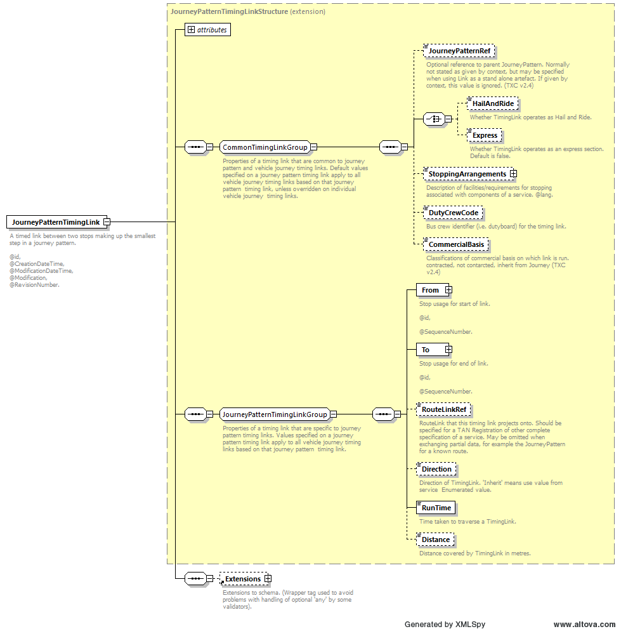
Figure 23 - Overview of JourneyPatternTimingLink element

Table 20 - Permitted elements in JourneyPatternTimingLink
Element Name | Data Type | Used in TXC-PTI
JourneyPatternRef | JourneyPatternRefStructure | Not used
HailAndRide | boolean | Not used
Express | boolean | Not used
StoppingArrangements | NaturalLanguageString | Not used
DutyCrewCode | DutyCrewCodeType | Omitted at this level. Use in VehicleJourney. See 9.7
CommercialBasis | LinkCommercialBasisEnumeration | Not used at this level. Use within Service or VehicleJourney. See sections 5.3.3 and 9.3
From | JourneyPatternStopUsageStructure | Mandated by schema. See 8.4.3
To | JourneyPatternStopUsageStructure | Mandated by schema. See 8.4.3
RouteLinkRef | RouteLinkRefStructure | Yes, shall be included.
Direction | JourneyPatternLinkDirection  Enumeration | Not used at this level.
RunTime | DurationType | Mandated by schema. Zero or value. See section 8.1
Distance | DistanceType | Where appropriate

For TXC-PTI, a JourneyPatternTimingLink shall be populated as follows:
- RouteLinkRef shall be populated with the id of the corresponding RouteLink.
- RunTime shall be populated either with the actual value of the run time over the link, or with a duration of zero minutes, as described in section 8.1.
- Distance may be populated if available. If it is populated, then it shall have the same value as the any Distance element or length of Track on the corresponding RouteLink.
- DutyCrewCode shall be omitted, as this is better placed in individual vehicle journeys.
- Direction shall be omitted from a JourneyPatternTimingLink. This permits reuse of sections and links where, for example, a section of a service is used in two different directions such as a loop through a town centre due to one-way systems.
- JourneyPatternRef, HailAndRide, Express, StoppingArrangements and CommercialBasis shall be omitted. The reference to the journey pattern is implied, and the other elements do not contain useful public-facing information. There might be some merit in describing a link as HailAndRide, but this would require detailed track information which is only recommended rather than mandatory, and it would have to apply to the whole of the link even if only part of it was hail and ride. Instead, specify hail and ride sections by reference to NaPTAN “virtual” hail and ride stops which have starts and ends of hail and ride sections defined.

In TXC-PTI, a JourneyPatternTimingLink shall have a RouteLinkRef and RunTime, and may have a Distance. It shall additionally have From and To elements but shall not have other elements. Specifically, it shall not have a Direction element.
➲
The validator checks to ensure that Direction is not provided.

    - Stop definition and wait times
Every JourneyPatternTimingPointLink requires a From element, detailing the departure stop and activity, and a To element, detailing the arrival stop and activity. These two elements are constructed the same way, using a JourneyPatternStopUsageStructure.
In versions of TXC prior to v2.4, the intent of these structures was that they were additive. That is, they combined to give an overall effect for activity at the stop, remembering that the arrival stop (To element) on one link is the same physical stop point as the departure stop (From element) on the next successive link. So, for example, if a To element defined a stop as “set down only” and a From element defined a stop as “pick up only” then the overall effect was that it allowed both setting down and picking up.
One area where this caused particular confusion was with wait times. Both arrival and departure settings could define a wait time – the intention was, originally, to be able to specify an unloading time and a loading time separately, although in practice this rarely if ever happened.
In TXC v2.4, this behaviour fundamentally changed. The schema guidance, unfortunately, did not reflect this, but it is clear from the schema. From version 2.4 onwards, the wait time was to be the total wait time and was to be stated identically on both the To element of the incoming link and the From element of the next, outgoing link.

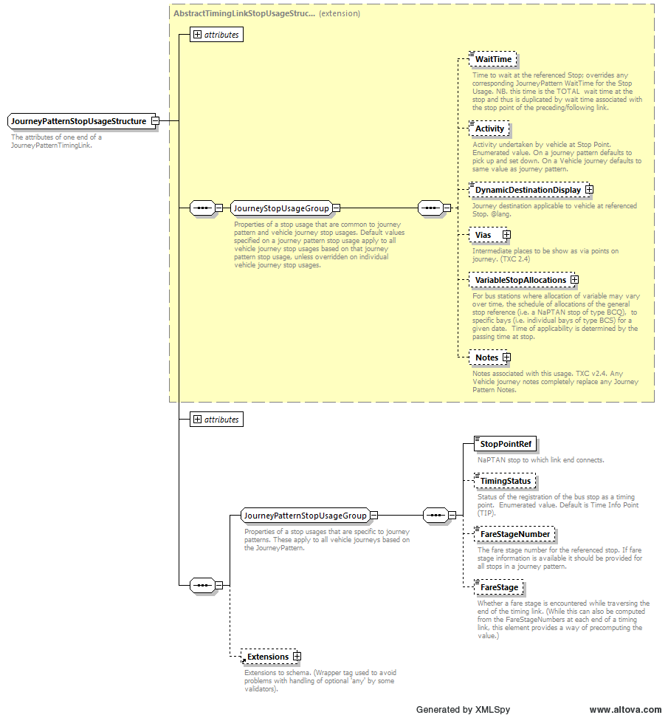
Figure 24 - The JourneyPatternStopUsage structure
TXC-PTI is making this requirement explicit. Moreover, there are additional benefits to making as many of the other elements as possible behave the same way, as this aids readability and is unequivocal as to what is happening at the stop. Some elements still cannot be treated this way, however, and these are outlined below.
A From or To element in a JourneyPatternTimingLink in TXC-PTI shall therefore use the elements and values for a JourneyPatternStopUsageStructure shown in the table below.

Table 21 - Permitted elements and values in a TXC-PTI JourneyPatternStopUsageStructure
Element Name | Data Type | Use in TXC-PTI
WaitTime | DurationType | The total wait time at the stop, which is to be duplicated on the To end of the incoming link and the From end of the next, outgoing link.  Shall be included where appropriate.
Activity | VehicleAtStopActivity  Enumeration | The activity at the stop, which is to be duplicated on the To end of the incoming link and the From end of the next, outgoing link.  Shall always be included if the behaviour is not the default pickUpAndSetDown.  Permitted values are pickup, setDown, pickUpAndSetDown and pass.  The majority of stops will inherit the TXC default of pickUpAndSetDown.
DynamicDestinationDisplay | NaturalLanguageString | A textual description of the destination of the vehicle which may be shown at this stop. This is different from the overall destination of the journey pattern and can vary along the route. It is particularly useful for circular services where, for example, the destination shown at the first stop would otherwise be the same stop.  Shall always be included if neither JourneyPattern/DestinationDisplay nor VehicleJourney/Destination is included and shall be included if appropriate otherwise.
Vias | ViasStructure | Not used.
VariableStopAllocations | VariableStopAllocations  Structure | Not used.
Notes | NotesStructure | May be included where appropriate. See section 2.5. May be different on the To end of the incoming link and the From end of the next, outgoing link.
StopPointRef | StopPointRefStructure | The AtcoCode of a referenced NaPTAN stop point defined in an AnnotatedStopPointRef, or the pseudo-AtcoCode of the operator-defined stop point defined in a StopPoint. It is duplicated on the To end of the incoming link and the From end of the next, outgoing link as it is the same stop.
TimingStatus | TimingStatusEnumeration | Defines the reliability of the timing at the stop and may also be used as a flag to aid in the display of “main point” timetables.  Shall always be included.  TXC v2.4 includes both the older three-letter codes as well as newer, more readable versions. To aid readability, only those values set out below shall be used in a TXC-PTI document.  Allowed values are:  principalTimingPoint (note: only this spelling)  otherPoint
FareStageNumber | FareStageNumberType | States the fare stage number for this stop. May be different on the To end of the incoming link and the From end of the next, outgoing link.  May be included where appropriate.
FareStage | boolean | A true/false flag which provides a simple way to determine if a fare stage is changing at this stop. It is to be duplicated on the To end of the incoming link and the From end of the next, outgoing link.  May be included where appropriate.
➲
In TXC-PTI, a From element and the To element on the next link shall have the same information for the stop, except for those elements identified above.

Within JourneyPatternSections, if there are two JourneyPatternTiminglinks, A and B that follow on from each other. The details about the 'To' stop from link A shall be the same as for the 'From' stop in link B.
If neither JourneyPattern/DestinationDisplay nor VehicleJourney/Destination is included, then DynamicDestinationDisplay at JourneyPatternStopUSageStructure level should be included otherwise a validation error will occur.
Tests to ensure that the Activity for a stop is set correctly are included in the Data Quality tests. This identifies where the first stop is designated as set down only and the last stop is designated to be pick up only which are incorrect.

    - Formatting for timetable displays
One of the common problems with TXC data is how disparate trips on different days of the week can be structured into a traditional matrix timetable, and one of the goals of the TXC-PTI profile was to facilitate this where possible.
To achieve this, a TXC-PTI document shall use the sequenceNumber attribute of a JourneyPatternTimingLink.
The sequence number is not, as has sometimes been seen, simply a number which represents the order of links in a particular JourneyPatternSection. Rather, it is a number which represents that stop’s position in a row on a timetable. This is best illustrated by considering the following timetable:

Table 22 - Example of a structured timetable
Seq. No. | Name | AtcoCode | Trip 1 | Trip 2
1 | One | 1580ABCD | 08:00 | 08:15
2 | Two | 1580EFGH | 08:02 | 08:17
3 | Three | 1580JKLM | | | 08:23
4 | Four | 1580NPQR | 08:07 | -

In TXC-PTI, this shall be coded in this way:
<JourneyPatternSection id="ABC1_jps1">
  - <JourneyPatternTimingLink id="ABC1_jps1_tl1">
    - <From SequenceNumber="1">
      - <StopPointRef>1580ABCD</StopPointRef>
    - </From>
    - <To SequenceNumber="2">
      - <StopPointRef>1580EFGH</StopPointRef>
    - </To>
    - <RunTime>PT2M</RunTime>
  - </JourneyPatternTimingLink>
  - <JourneyPatternTimingLink id="ABC1_jps1_tl2">
    - <From SequenceNumber="2">
      - <StopPointRef>1580EFGH</StopPointRef>
    - </From>
    - <To SequenceNumber="4">
      - <StopPointRef>1580NPQR</StopPointRef>
    - </To>
    - <RunTime>PT5M</RunTime>
  - </JourneyPatternTimingLink>
</JourneyPatternSection>
<JourneyPatternSection id="ABC1_jps2">
  - <JourneyPatternTimingLink id="ABC1_jps2_tl1">
    - <From SequenceNumber="1">
      - <StopPointRef>1580ABCD</StopPointRef>
    - </From>
    - <To SequenceNumber="2">
      - <StopPointRef>1580EFGH</StopPointRef>
    - </To>
    - <RunTime>PT2M</RunTime>
  - </JourneyPatternTimingLink>
  - <JourneyPatternTimingLink id="ABC1_jps2_tl2">
    - <From SequenceNumber="2">
      - <StopPointRef>1580EFGH</StopPointRef>
    - </From>
    - <To SequenceNumber="3">
      - <StopPointRef>1580JKLM</StopPointRef>
    - </To>
    - <RunTime>PT6M</RunTime>
  - </JourneyPatternTimingLink>
</JourneyPatternSection>

Note the SequenceNumber usage in the From and To elements; it is clear from the numbering used which order the stops should appear, and which times shall appear against which stops.
➲
In TXC-PTI, a JourneyPatternTimingLink shall use the SequenceNumber attribute in the From and To elements in order to facilitate the correct layout of a timetable.

The validator tests checks that within the JourneyPatternTimingLink, the "From SequenceNumber" and "To SequeneceNumber" are populated.

- Vehicle journeys
  - Introduction
In TXC, the VehicleJourney element defines the actual trip that a vehicle will make. Up to this point, the TXC has been defining the basic parameters of the service, the routings of the vehicles, the default timings of the links, etc., but this is the section of the TXC document where the actual departures are specified. It is essential that this information is correctly structured and reflects what the vehicle will do.
TXC-PTI adopts the approach that the best place to hold the information about a trip is within the trip itself. To that end it recommends that much of the detail about the trip, and in particular the dates on which the trip operates, be contained within the VehicleJourney and not elsewhere. However, for reasons of readability and compactness it is possible to define default patterns and timings that suit the majority of the trips, and then override them in individual vehicle journeys where appropriate. In this case, though, complete sets of information shall be overridden, and the systems shall not rely on inheriting only parts of data elements as this leads to confusion and errors of interpretation.
  - Basic structure of a vehicle journey
    - Introduction
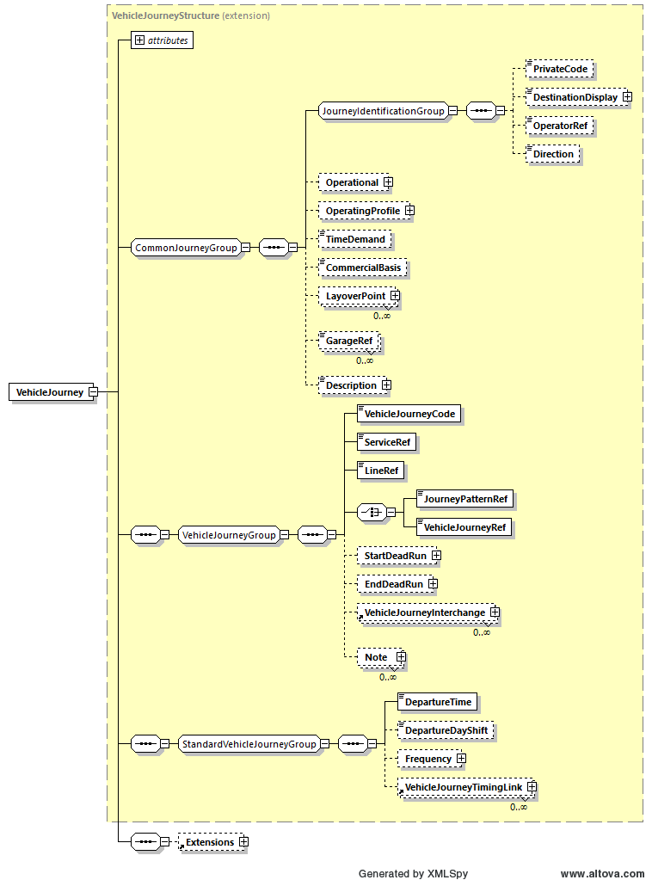
Figure 25 - Basic structure of a VehicleJourney
A vehicle journey record is structured as shown in the figure above. Many of these elements are described in more detail in the sections that follow. In general terms, however, a VehicleJourney in TXC-PTI has the usage outlined in the table below.

Table 23 - Usage of elements in a VehicleJourney
Element Name |  | Data Type | Used in TXC-PTI
PrivateCode |  | PrivateCodeType | Where appropriate
DestinationDisplay |  | NaturalLanguageString | Yes, shall be provided if not using DestinationDisplay or DynamicDestinationDisplay at a JourneyPattern level.
OperatorRef |  | OperatorRefStructure | Yes, shall be included. Reference to defined Operator
Direction |  | JourneyPatternVehicleDirection  Enumeration | Not used at this level.
Operational |  | OperationalStructure | Where appropriate, shall be included to support real time information. See section 9.7. May also includes VehicleType information – see section 2.4.2
OperatingProfile |  | OperatingProfileStructure | Where appropriate to replace any definition in Service. See section 9.3
TimeDemand |  | TimeDemandEnumeration | Optional
CommercialBasis |  | JourneyCommercialBasis  Enumeration | Where appropriate
LayoverPoint |  | LayoverPointStructure | Where appropriate, shall be included to support real time information. See section 9.7.2
GarageRef |  | GarageRefStructure | Where appropriate, shall be included to support real time information. See section 9.7
Description |  | NaturalLanguageString | Optional
VehicleJourneyCode |  | VehicleJourneyCodeType | Mandated by schema
ServiceRef |  | ServiceRefStructure | Mandated by schema
LineRef |  | LineIdType | Mandated by schema
(one of) | JourneyPatternRef | JourneyPatternIdType | Mandated by schema (if VehicleJourneyRef not present)
(one of) | VehicleJourneyRef | VehicleJourneyCodeType | Mandated by schema (if JourneyPatternRef not present)
StartDeadRun |  | DeadRunStructure | Where appropriate, shall be included to support real time information. See section 0
EndDeadRun |  | DeadRunStructure | Where appropriate, shall be included to support real time information. See section 0
VehicleJourneyInterchange |  | VehicleJourneyInterchange  Structure | Where appropriate. See section 9.6
Note |  | NoteStructure | Where appropriate.
DepartureTime |  | time | Mandated by schema
DepartureDayShift |  | integer | Where appropriate. If present, shall be +1. See section 9.5
Frequency |  | FrequentServiceStructure | Where appropriate. No special rules in TXC-PTI; refer to TXC schema guidance.
VehicleJourneyTimingLink |  | VehicleJourneyTimingLink  Structure | Where appropriate for providing a complete set of timing links at VehicleJourney level. See section 9.4

A TXC-PTI VehicleJourney:
- shall have a VehicleJourneyCode, a ServiceRef and a LineRef as mandated by the schema. TXC-PTI does not specify how a VehicleJourneyCode is to be structured, and this can be done to suit the originating system. It may however be useful to include the line ref as part of the code.
- shall have a DestinationDisplay where neither this nor a DynamicDestinationDisplay is provided at a JourneyPattern level.
- shall have either a JourneyPatternRef, referencing a JourneyPattern, or a VehicleJourneyRef, referencing another VehicleJourney.
In general, most VehicleJourneys would refer to a JourneyPattern via a JourneyPatternRef. This allows the VehicleJourney to refrence any timings declared in that JourneyPattern and to either use the default OperatingProfile or provide a complete replacement for it.
However, in some cases and particularly where another VehicleJourney has already been defined with the correct days of operation and a full set of times, the VehicleJourney can reference that other vehicle journey’s VehicleJourneyCode using a VehicleJourneyRef.
If a VehicleJourneyRef is used then all the details of the referenced VehicleJourney, including operating profile, timings, vehicle types, etc. shall be inherited and not overridden. The only elements that may be amended are the operational elements for real time systems.
- shall have a DepartureTime to say what time the VehicleJourney starts, and may optionally shift trips to the next day using DepartureDayShift (see section 9.5) or define them as frequent journeys using Frequency (refer to TXC schema guidance for specifying frequent journeys).
- may override the operating days by providing a complete set of days and dates when the trip operates using an OperatingProfile block (section 9.3)
- may override the vehicle timings by providing a complete set of times over all of the links in a journey pattern in a set of VehicleJourneyTimingLink elements (see section 9.4).
- shall have an Operational block and set of GarageRef elements containing information to support real time systems, where such information is available (see section 9.7).
- may include dead runs (as StartDeadRun and EndDeadRun) where appropriate (see section 9.7).
- may have a PrivateCode for compatibility with legacy systems.
- may include information on interchanges where appropriate (see section 9.6).
- may include a CommercialBasis flag to denote whether or not the service is operated commercially (notContracted) or whether it is wholly or partially contracted (contracted, partContracted). While this is of limited use to the public, contracting authorities are keen to demonstrate their role in providing socially necessary services. This flag is optional, and may have a default set at Service level. At this level, it denotes that this specific trip (and any others referencing it via VehicleJourneyRef) has the stated commercial basis.
- may define one or more LayoverPoints to assist in real time information. LayoverPoints are referenced in dead runs (either StartDeadRun or EndDeadRun). See section 0. LayoverPoints shall only be defined in a VehicleJourney if not present in the referenced JourneyPattern or referenced VehicleJourney.

➲
In TXC-PTI, a VehicleJourney shall define the operation of a particular trip, optionally overriding some of the blocks so long as these are complete replacements. Some elements are not to be used.
If a VehicleJourneyRef is provided within a ‘VehicleJourney’, then ‘OperatingProfile’ is not allowed and will raise an error if provided. If VehicleJourneyTimingLink is provided in VehicleJourney,then the number of links provided should be same as number of JourneyPatternTimingLinks provided in JourneyPattern otherwise an error is raised.
If DestinationDisplay or DynamicDestinationDisplay at a JourneyPattern level is not used, then DestinationDisplay is a mandatory element within VehicleJourney and if not provided will raise an error in the validator.

    - Formatting for timetable displays
As with stops read down a timetable, one of the common problems with TXC data is how disparate trips on different days of the week can be structured across a traditional matrix timetable, and one of the goals of the TXC-PTI profile was to facilitate this where possible.
To achieve this, a TXC-PTI document may use the sequenceNumber attribute of a VehicleJourney.
The sequence number is not, as has sometimes been seen, simply a number which represents the order of the records in a particular set of VehicleJourneys. Rather, it is a number which represents that trip’s position in a column on a timetable. This is best illustrated by considering the same timetable as before:

Table 24 - Example of a structured timetable
Seq. No. | Name | AtcoCode | Trip 1 | Trip 2
1 | One | 1580ABCD | 08:00 | 08:15
2 | Two | 1580EFGH | 08:02 | 08:17
3 | Three | 1580JKLM | | | 08:23
4 | Four | 1580NPQR | 08:07 | -

In TXC-PTI, this shall be coded in this way:

<VehicleJourneys>
  - <VehicleJourney SequenceNumber="1" >
    - <VehicleJourneyCode>Trip_1</VehicleJourneyCode>
    - ...
  - </VehicleJourney>
  - <VehicleJourney SequenceNumber="2">
    - <VehicleJourneyCode>Trip_2</VehicleJourneyCode>
    - ...
  - </VehicleJourney>
  - ...
</VehicleJourneys>
Note the SequenceNumber usage in the VehicleJourney elements; it is clear from the numbering used which order the trips should appear. However, care does have to be taken when creating sequence numbers to give some thought as to how the trips are to be presented, because the order can vary depending on how trips are to be combined – for example, on a “Mondays to Saturdays” timetable compared to separate “Mondays to Fridays” and “Saturdays” timetables. For this reason, sequence numbers on vehicle journeys are optional in TXC-PTI, although they are recommended.
➲
In TXC-PTI, a VehicleJourney may use the SequenceNumber in order to facilitate the correct layout of a timetable. This is recommended.

  - The OperatingProfile
    - Basic structure of an OperatingProfile
An OperatingProfile details the regular and irregular operation of a trip.
It consists of a NormalDayPropertiesGroup, which defines the regular operation, broken down into regular days which are then qualified (restricted) by periodic elements (e.g. 1st Wednesday of each month) or by serviced organisation dates (such as school term dates).
In addition to the regular days, elements also exist to add or remove specific date ranges, and to add or remove specific bank holidays (either enumerated or user-defined). Each of these has days of operation, which are in addition to any defined regular days, and days of non-operation, which remove any previously defined regular days.

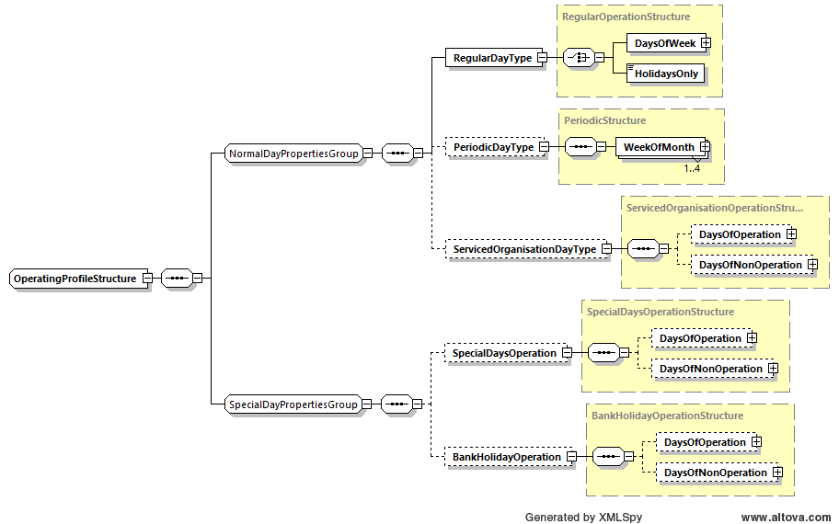
Figure 26 - Basic structure of an OperatingProfile

As with TXC, in the event of conflict between days of operation and days of non-operation, the days of non-operation shall take precedence i.e. in the case of doubt, a trip shall be taken as not operating.
The usage of these within TXC-PTI is as in the table below, described more fully in the sections which follow.

Table 25 - Usage of elements in OperatingProfile
Element Name |  |  | Data Type | Used in TXC-PTI
Regular Day Type |  |  | RegularOperationStructure | Mandated by schema
 | (one of) | DaysOfWeek
 | (one of) | HolidaysOnly | EmptyType | Used instead of DaysOfWeek if no regular days of operation are defined.
PeriodicDayType |  |  | PeriodicStructure | Where appropriate. See section 9.3.3
ServicedOrganisationDayType |  |  | ServicedOrganisationOperation  Structure | Where appropriate. See section 9.3.6
SpecialDaysOperation |  |  | SpecialDaysOperationStructure | Where appropriate. See section 9.3.4
BankHolidayOperation |  |  | BankHolidayOperationStructure | Where appropriate. See section 9.3.5

    - Regular days
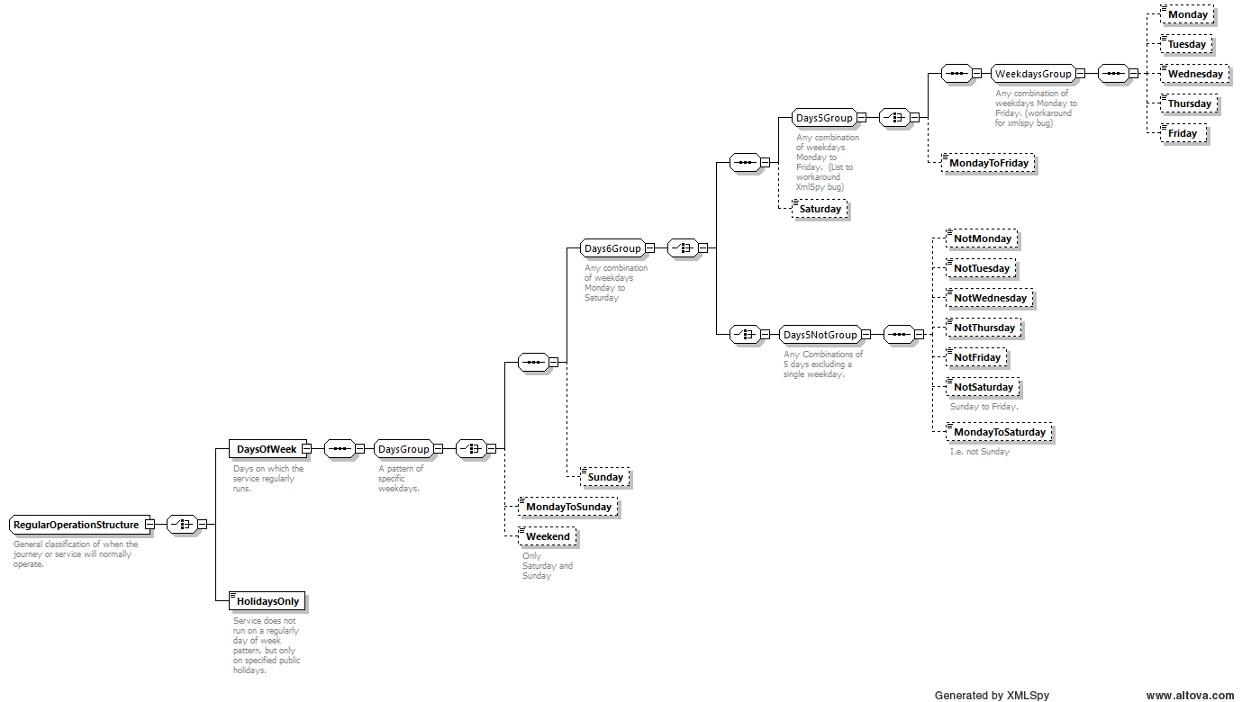
Figure 27 - The RegularOperationStructure
In TXC, there is an expectation that some degree of regular operation will be defined. Indeed, it is mandated by the schema. There is a degree of confusion as to how the different elements all interact, however, and even more confusion when it comes to the groupings of regular days that can be used as enumerations.
Consider the structure for regular days shown in the figure above. Individual days are clear, as is the intent of some group enumerations such as MondayToSunday, MondayToSaturday and MondayToFriday. However, it becomes much less clear when looking at some of the other grouping enumerations. NotSaturday, for example, is annotated with text that describes it as “Sunday to Friday” but as part of a group identified as being a combination of 5 days excluding a single weekday, whereas “weekdays” is a group consisting only of the five individual days of the working week excluding Saturday and Sunday. Furthermore, NotThursday (for example), which is unannotated, would suggest a similar structure to NotSaturday i.e. Friday to Wednesday. This type of operation seems unlikely.
Because of this potential confusion, and the principle in TXC-PTI to make data clear and specific wherever possible, TXC-PTI shall therefore only use named, individual days of the week and shall not use the group enumerations.
The following example illustrates the use of RegularDayType to define a service which operates Mondays, Wednesdays and Fridays.
<RegularDayType>
  - <!-- Not Tuesdays or Thursdays -->
  - <DaysOfWeek>
    - <Monday/>
    - <Wednesday/>
    - <Friday/>
  - </DaysOfWeek>
</RegularDayType>

Note, particularly, that it is not correct in TXC-PTI to define all days of the week and then remove Tuesdays and Fridays through SpecialDaysNonOperation.
➲
In TXC-PTI, all regular days of operation shall be explicitly stated. Grouping enumerations shall not be used.
If a grouping enumeration is provided the validator will raise an error.

    - Periodic days
In TXC, periodic days are even less well understood, and consequently are rarely used. These define services which operate on e.g. 1st and 3rd Wednesdays of each month. Such restrictions are often to be found in community transport services taking rural passengers to town market days; these are not their only uses, however.
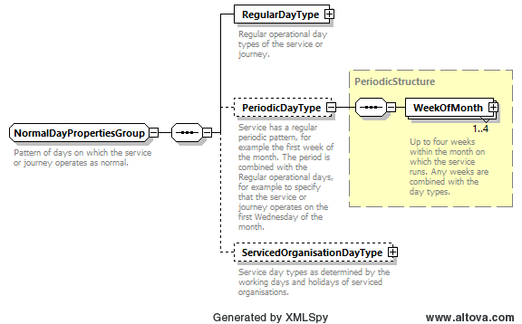
Figure 28 – The NormalDayPropertiesGroup/PeriodicDayType structure
Traditionally, TXC has tended to encode these services with specific SpecialDaysOperation dates. There are, however, two issues with this. The first is that simply having a set of dates does not provide any sort of context as to why those particular dates; the second, potentially more problematic for an operator maintaining data, is that the files have to be continuously refreshed as sets of date ranges expire.
For that reason, in TXC-PTI wherever a trip or service operates on regular, periodic days, then this shall be defined using the PeriodicDayType element available in TXC. This element works in conjunction with the RegularDayType element: RegularDayType states which day(s) of the week the trip or service operates, while PeriodicDayType indicates, through a set of week number enumerations, which weeks in that month it operates.
As with all operational day elements, serviced organisations and days of non-operation further qualify these dates – see relevant sections for details.
The previously quoted example, of a service which operates on the 1st and 3rd Wednesdays of each month, would be coded like this in TXC-PTI:
<RegularDayType>
  - <!—Wednesdays only -->
  - <DaysOfWeek>
    - <Wednesday/>
  - </DaysOfWeek>
</RegularDayType>
<PeriodicDayType>
  - <!-- Repeated WeekOfMonth elements, one for each week of operation -->
  - <!-- Here,first and third so that overall effect is 1st & 3rd Wednesdays -->
  - <WeekOfMonth>
    - <WeekNumber>first</WeekNumber>
  - </WeekOfMonth>
  - <WeekOfMonth>
    - <WeekNumber>third</WeekNumber>
  - </WeekOfMonth>
</PeriodicDayType>

Note that the WeekNumber element is an enumeration, and not a number. Possible values are first, second, third, fourth, fifth, and last.
➲
In TXC-PTI, all regular periodic operation shall be coded using the PeriodicDayType element, and not with individual date ranges.
The validator tests for the use of enumerated values in WeekOfMonth and WeekNumber, providing an integer will trigger an error in validation.

    - Special days
Special days are the method by which additional regular, irregular, or one-off dates or exclusions can be set up for trips. Such trips can include festival services, shuttle services which only operate when points of interest are open, football services, and similar.
Special days are structured with two distinct sections: DaysOfOperation, describing the additional dates that the trip or service operates; and DaysOfNonOperation, describing the dates when the service does not operate. In both cases a series of date ranges is included, with inclusive StartDate and EndDate elements and a Note if required.
Note that, in TXC and consequently also in TXC-PTI, special days DaysOfOperation are additive; that is they operate in addition to any other stated days. This is true even if the special day occurs on a different day of the week to the stated regular days. This is particularly important to note if a range of dates is defined, since the trip or service would operate on every single day within that date range.
Where a trip or service is only operating on a particular set of dates, and does not have a regular day type, the coding HolidaysOnly shall be used in RegularDayType in place of DaysOfWeek.

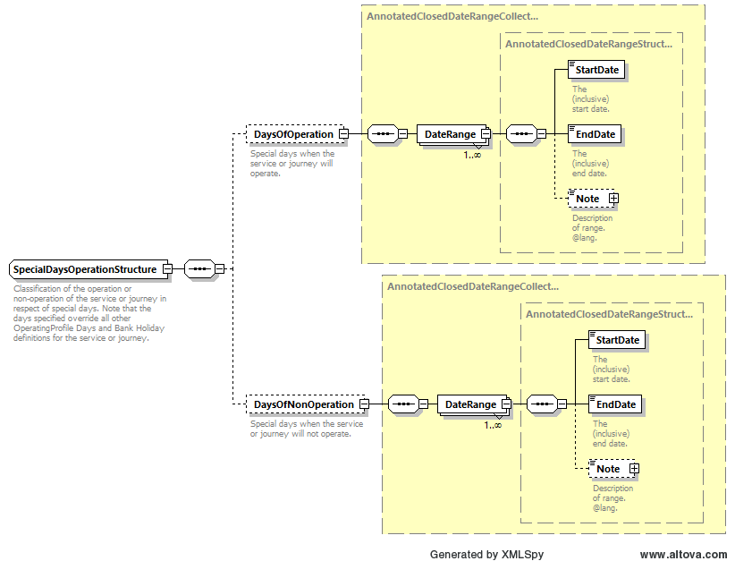
Figure 29 - The structure of special days
For example, the following code would define a trip which operated only during a four-day event:
  - <OperatingProfile>
      - <RegularDayType>
        - <!—No regular operation -->
        - <HolidaysOnly/>
      - </RegularDayType>
      - <SpecialDaysOperation>
        - <DaysOfOperation>
          - <!-- Festival operation – trip operates on all dates in range -->
          - <DateRange>
            - <StartDate>2020-07-30</StartDate>
            - <EndDate>2020-08-02</EndDate>
          - </DateRange>
        - </DaysOfOperation>
      - </BankHolidayOperation>
  - </OperatingProfile>

On the contrary, DaysOfNonOperation are restrictive (or subtractive); that is, they restrict the already stated days of operation. These could cover, for example, one-off events such as marathons which take place on known dates, but which temporarily disrupt services. For example:
  - <OperatingProfile>
      - <RegularDayType>
        - <!-- Sunday operation -->
        - <DaysOfWeek>
          - <Sunday/>
        - </DaysOfWeek>
      - </RegularDayType>
      - <SpecialDaysOperation>
        - <DaysOfNonOperation>
          - <!-- Great North Run 2020 -->
          - <DateRange>
            - <StartDate>2020-09-13</StartDate>
            - <EndDate>2020-09-13</EndDate>
          - </DateRange>
        - </DaysOfNonOperation>
      - </BankHolidayOperation>
  - </OperatingProfile>

The general principle in TXC-PTI is that dated ranges should only be used as a last resort. Often, trips are better coded, and contain more contextual information, using regular day types, periodic days, named bank holidays (whether using built-in enumerations or especially created) or serviced organisations. See other sections for more detail.
➲
In TXC-PTI, special operating dates shall be used only as a last resort when all other options have been explored.
In the operating profile, if SpecialDaysOperation is used but no other day type (RegularDayType, PeriodicDayType or ServicedOrganisationDayType) is provided then a warning is raised.

    - Bank holidays
Bank holiday enumerations have proved to be problematic to some users, particularly those in Scotland. This is because systems have tended to use groups of bank holidays, such as AllBankHolidays to simplify the output. In certain jurisdictions, though, these groups contain bank holidays with assigned dates that are not universally recognised. This causes normal operations to drop out of systems unexpectedly and results in significant work to correct.
One solution that was proposed is to dispense with the encoded bank holidays entirely and to rely on dated ranges to state when trips did and did not run. However, this is to throw out a significant degree of context provided by e.g. “does not run on Good Friday”.
An alternative solution proposed using facilities in TXC to define only those bank holidays that were required, using special date ranges. However, this option was also discounted as it could lead to conflicts when named bank holidays were created for holidays that were already enumerated.
TXC-PTI has therefore adopted the principle that grouping elements shall not be used, and all bank holidays shall be explicitly stated in their appropriate DaysOfOperation and/or DaysofNonOperation structures. This is in line with the principles already discussed for regular days of operation above, and allows contextual bank holiday operation to be provided while removing problematic bank holidays from consideration.
Within the TXC bank holiday enumeration there are two days that are not strictly bank holidays – ChristmasEve and NewYearsEve. The for the purposes of TXC and the TXC-PTI these days are to be regarded as bank holidays and should be coded as such.
Note that nothing in the foregoing prevents additional bank holidays being defined using the OtherPublicHoliday element, as some special days are introduced from time to time such as the Royal Wedding and Queen’s Jubilee additional days in 2012. For the structure of the OtherPublicHoliday element, please refer to the TXC schema guidance.
For an example of bank holiday coding, consider the following snippet of XML. As structured, this would prevent a trip from operating Christmas Day, Boxing Day, New Year’s Day, the 2nd January holiday in Scotland, and Easter Monday, but would allow it to continue running on St Andrews Day and a Scottish summer bank holiday, neither of which are routinely observed.
<BankHolidayOperation>
  - <DaysOfNonOperation>
    - <ChristmasDay/>
    - <BoxingDay/>
    - <NewYearsDay/>
    - <Jan2ndScotland/>
    - <EasterMonday/>
  - </DaysOfNonOperation>
</BankHolidayOperation>
➲
In TXC-PTI, all bank holidays with enumerations shall be explicitly stated within the DaysOfOperation and/or DaysOfNonOperation blocks. Grouping enumerations shall not be used.
For services that operate wholly within England and Wales the following are the bank holidays that must be explicitly coded either as DaysOfOperation or DaysOfNonOperation:
• ChristmasEve
• NewYearsEve
• ChristmasDay
• ChristmasDayHoliday
• BoxingDay
• BoxingDayHoliday
• NewYearsDay
• NewYearsDayHoliday
• GoodFriday
• EasterMonday
• MayDay
• SpringBank
• LateSummerBankHolidayNotScotland

The coding of Scottish bank holidays is not mandatory, services with one or more stops in Scotland are recommended to code the additional days to ensure that Scottish data consumers receive accurate data:
• Jan2ndScotland
• Jan2ndScotlandHoliday
• StAndrewsDay
• StAndrewsDayHoliday
• AugustBankHolidayScotland

As a result of the approach that TXC takes to specify bank holidays and movable day of the week for some bank holidays, for example Boxing Day and New Year’s day it is important that the TXC files submitted to BODS reflect the correct operation from year to year. It is probable that even if the timetable has not changed between years that TXC files will need to be re-submitted to ensure that bank holiday and DaysOfOperation data are correctly supplied.

Note that, in TXC and consequently also in TXC-PTI, bank holiday DaysOfOperation are additive; that is they operate in addition to any other stated days. This is true even if the bank holiday occurs on a different day of the week to the stated regular days. For example, the following code would define a trip which operated “Sundays and Bank Holidays (excluding Christmas and New Year)” in England:
  - <OperatingProfile>
      - <RegularDayType>
        - <!-- Sunday operation -->
        - <DaysOfWeek>
          - <Sunday/>
        - </DaysOfWeek>
      - </RegularDayType>
      - <BankHolidayOperation>
        - <DaysOfOperation>
          - <!-- Additional bank holiday operation -->
          - <GoodFriday/>
          - <LateSummerBankHolidayNotScotland/>
          - <MayDay/>
          - <EasterMonday/>
          - <SpringBank/>
        - </DaysOfOperation>
      - </BankHolidayOperation>
  - </OperatingProfile>

On the contrary, DaysOfNonOperation are restrictive (or subtractive); that is, they restrict the already stated days of operation. For example, a trip which is Mondays to Fridays excluding bank holidays would be coded as shown below.
  - <OperatingProfile>
      - <RegularDayType>
        - <!-- Weekday operation -->
        - <DaysOfWeek>
          - <Monday/>
          - <Tuesday/>
          - <Wednesday/>
          - <Thursday/>
          - <Friday/>
        - </DaysOfWeek>
      - </RegularDayType>
      - <BankHolidayOperation>
        - <DaysOfNonOperation>
          - <!-- Bank holiday non-operation -->
          - <ChristmasDay/>
          - <BoxingDay/>
          - <GoodFriday/>
          - <NewYearsDay/>
          - <LateSummerBankHolidayNotScotland/>
          - <MayDay/>
          - <EasterMonday/>
          - <SpringBank/>
        - </DaysOfNonOperation>
      - </BankHolidayOperation>
  - </OperatingProfile>

    - Referencing serviced organisations
The coding and the application of serviced organisations has already been covered in section 0 above, and reference was made there to the way in which they are encoded in TXC-PTI VehicleJourneys.
To reiterate the fundamental point made in that earlier section, in TXC-PTI a serviced organisation shall only be provided with dates for working days, and all other dates shall be assumed to be holidays. This means that trips which operate on working (e.g. school) days only are coded as DaysOfOperation/WorkingDays, while trips which only operate during the holidays will be encoded as DaysOfNonOperation/WorkingDays.
An additional consideration for using serviced organisation dates within a TXC-PTI file is the manner in which the ServicedOrganisation interacts with the regular days. This is something which causes a degree of confusion in TXC, and it is important to note that serviced organisation dates restrict (are logically ANDed with) the days of the week provided in the RegularDayType element. So, for schools, for example, which by and large operate Mondays to Fridays, this pattern can be stated as the regular days of operation. The dates provided for the serviced organisation then list the range of dates during which those Mondays to Fridays apply.
Thus, there is no need for a ServicedOrganisation to define an entire half-term’s worth of Monday to Friday dates. It is far simpler to define a single date range for the half term (e.g. 5 September – 18 October) and use the RegularDayType to limit this to Mondays to Fridays within that date range. This is much simpler to code and to interpret / debug.
This principle also carries forward into bank holidays. For the most part, bank holidays usually fall within school holidays. However, depending on the date of Easter and the Early May Holiday, some bank holidays can occur during term time. Given that dates of non-operation further limit the standard operation, it follows that there is no need to exclude bank holidays from the range of working days.
For example:
<ServicedOrganisation>
  - <OrganisationCode>HPFLD</OrganisationCode>
  - <Name>Harrop Fold School</Name>
  - <WorkingDays>
  - <DateRange>
      - <StartDate>2020-02-24</StartDate>
      - <EndDate>2020-04-03</EndDate>
      - <Description>Spring Term 2020 – second half</Description>
  - </DateRange>
  - <DateRange>
      - <!-- Date range omits 9 May bank holiday -->
      - <StartDate>2020-04-20</StartDate>
      - <EndDate>2020-05-22</EndDate>
      - <Description>Summer Term 2020 – first half</Description>
  - </DateRange>
  - <DateRange>
      - <StartDate>2020-06-01</StartDate>
      - <EndDate>2020-07-16</EndDate>
      - <Description>Summer Term 2020 – second half</Description>
  - </DateRange>
  - </WorkingDays>
</ServicedOrganisation>
...
<VehicleJourneys>
  - <VehicleJourney SequenceNumber="1">
  - <OperatingProfile>
      - <RegularDayType>
        - <!-- Weekday operation -->
        - <DaysOfWeek>
          - <Monday/>
          - <Tuesday/>
          - <Wednesday/>
          - <Thursday/>
          - <Friday/>
        - </DaysOfWeek>
      - </RegularDayType>
      - <ServicedOrganisationDayType>
        - <DaysOfOperation>
          - <!-- Weekdays restricted by the dates for organisation HPFLD -->
          - <WorkingDays>
            - <ServicedOrganisationRef>HPFLD</ServicedOrganisationRef>
          - </WorkingDays>
        - </DaysOfOperation>
      - </ServicedOrganisationDayType>
      - <BankHolidayOperation>
        - <DaysOfNonOperation>
          - <!-- Bank holiday non-operation further excludes 9 May -->
          - <!-- (MayDay in 2020) -->
          - <ChristmasDay/>
          - <BoxingDay/>
          - <GoodFriday/>
          - <NewYearsDay/>
          - <LateSummerBankHolidayNotScotland/>
          - <MayDay/>
          - <EasterMonday/>
          - <SpringBank/>
        - </DaysOfNonOperation>
      - </BankHolidayOperation>
  - </OperatingProfile>
  - ...
  - </VehicleJourney>
  - ...
</VehicleJourneys>
➲
In TXC-PTI, serviced organisation dates restrict the regular day types, and are themselves further restricted by bank holiday non-operation. Thus, working date ranges for serviced organisations shall be stated simply.

  - Trip timings
As has previously been stated, the assumption in TXC-PTI is that information relating to a trip shall be fully defined within a trip. However, for reasons of compactness and readability it can be desirable, at times, to define some of this information at a higher level. TXC-PTI therefore allows this to happen, so long as any difference in a VehicleJourney is indicated by a complete replacement of the relevant blocks.
This is true for times at stop (or, more precisely, the times over the links in the vehicle journey). As described in section 0, a JourneyPattern can be defined with run times of zero minutes over each link, with the actual times specified in each VehicleJourney. This is accomplished using a series of VehicleJourneyTimingLink elements, with the link times provided in the RunTime element, and the WaitTime (if any) defined in both the To stop at the end of one link and the From stop at the start of the next link.
A VehicleJourneyTimingLink has a similar – but not identical – set of elements a JourneyPatternTimingLink, and it is instructive to compare the structure shown below with Figure 23 in section 8.4. It can be seen that:
- A VehicleJourneyTimingLink has a reference back to the original JourneyPatternTimingLink via the JourneyPatternTimingLinkRef element.
- The From and To elements do not refer to the stop since this is inherited from the referenced journey pattern.
- In addition, for TXC-PTI the stop activity shall also be inherited from the journey pattern and not repeated in the vehicle journey. This is because, in general, it is unlikely that a stop will change whether it is set down or not (etc.) between trips. Note that timing point status is always inherited as there is no mechanism to override it in TXC.
- The common timing link group is common to both VehicleJourneyTimingLink and JourneyPatternTimingLink, and the same rules apply.

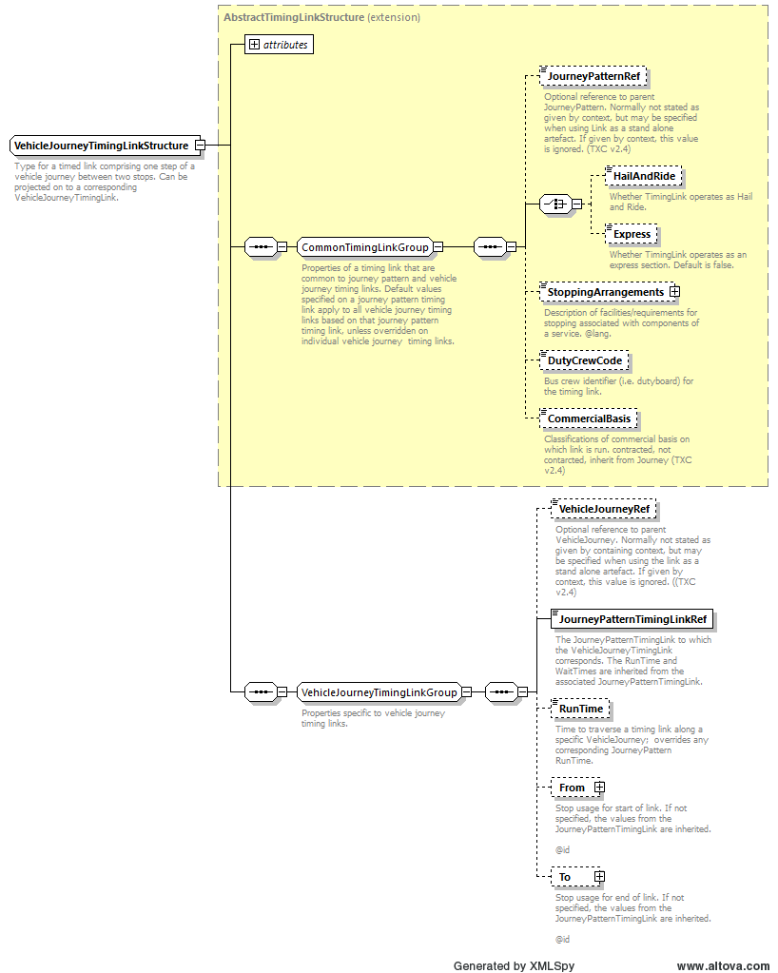
Figure 30 - The VehicleJourneyTimingLink structure

It should be noted that a VehicleJourney does not have the same Pattern > Section > Link structure as a JourneyPattern; VehicleJourneyTimingLink elements form a continuous sequence. For TXC-PTI, there can be no missing links in this sequence – there must be a one-to-one mapping between the links in a set of VehicleJourneyTimingLink element and the underlying JourneyPattern that is referenced by the VehicleJourney. If any links are to be omitted, then a corresponding JourneyPattern omitting the same links must exist.

The table below shows the permitted elements for the VehicleJourneyTimingLink.

Table 26 - Permitted elements in VehicleJourneyTimingLink
Element Name | Data Type | Used in TXC-PTI
JourneyPatternRef | JourneyPatternRefStructure | Not used
HailAndRide | boolean | Not used
Express | boolean | Not used
StoppingArrangements | NaturalLanguageString | Not used
DutyCrewCode | DutyCrewCodeType | Optional
CommercialBasis | LinkCommercialBasisEnumeration | Not used at this level. Use within Service or VehicleJourney. See sections 5.3.3 and 9.3
VehicleJourneyRef | VehicleJourneyCodeType | Optional
JourneyPatternTimingLinkRef | JourneyPatternTimingLinkRef  Structure | Mandated by schema
RunTime | DurationType | Yes, shall be included and shall be the actual run time.
From | VehicleJourneyStopUsageStructure | May be included in order to provide a WaitTime or a different DynamicDestinationDisplay. Other elements shall not be used.  WaitTime shall match the WaitTime on the preceding To link
To | VehicleJourneyStopUsageStructure | May be included in order to provide a WaitTime or a different DynamicDestinationDisplay. Other elements shall not be used.  WaitTime shall match the WaitTime on the following From link

In TXC-PTI, where a default pattern is provided for timing links then this can be overridden by use of VehicleJourneyTimingLink. Where this is used then there shall be a one-to-one mapping to a JourneyPattern with the same set of links, and times shall be provided for all links and (where necessary) wait times. No links shall be omitted.
➲

  - Journeys after midnight
TXC is a calendar-based system, and trips are defined as running on the actual calendar day on which they operate. However, many operators use an “operational day” concept, with days which start at (for example) 03:00 and run until 02:59 the following day.
For many services this leads to trips which run after midnight being shown at the end of a timetable panel, belonging to the previous calendar day. For example, trips in larger towns and cities, especially those with a sizeable student population, will often run trips in the early hours of Saturday morning and Sunday morning. These are shown, respectively, at the end of a Monday to Friday panel, labelled “Fridays only” and at the end of a Saturday panel.
These types of journeys are often wrongly coded in TXC, or are coded in a way that makes it difficult for a consuming system to place them in the right place when presenting the information in a traditional timetable. For example, TXC exists where:
- trips are shown with the incorrect day type.
In the example above, this would result in a trip that should operate in the early hours of Saturday morning being shown with a “Friday” operating date meaning that is being described, incorrectly, as operating in the early hours of Friday morning.
- trips are shown with the correct day type but cause unnecessary complexity on timetables.
This is particularly true on a Monday, where trips on Sunday night into Monday are shown alongside similar, but differently timed, trips on other weekdays.
A number of different mechanisms were implemented in TXC v2.4 in order to overcome this limitation, some of which are more complicated than others. For example, there is scope for an operator to declare particular day types of their own and to map regular days and times into them. For TXC-PTI, though, this was considered too complicated and the aim was to have something that was simple to grasp, and not that different from the standardised, TXC v2.1, way of encoding data.
To that end, TXC-PTI trips which run after midnight shall use the DepartureDayShift coding. This is an offset that allows a trip to be coded to the correct operational day, but then given an offset as to when it actually runs. For TXC-PTI this shall only ever be “+1”. Shifting departures backwards, or forwards by a greater amount, shall not be permitted.
For example:
<VehicleJourney>
  - <!-- Trip runs operationally on Sunday -->
  - <!-- Trip shall be displayed at the end of the Sunday timetable -->
  - <!-- Trip physically runs at 00:15 on a Monday morning -->
  - <OperatingProfile>
    - <RegularDayType>
      - <DaysOfWeek>
        - <Sunday>
      - </DaysOfWeek>
    - </RegularDayType>
  - </OperatingProfile>
  - <VehicleJourneyCode>VJ1</VehicleJourneyCode>
  - <ServiceRef>S1</ServiceRef>
  - <LineRef>L1</LineRef>
  - <JourneyPatternRef>JP1</JourneyPatternRef>
  - <DepartureTime>00:15:00</DepartureTime>
  - <DepartureDayShift>+1</DepartureDayShift>
</VehicleJourney>
and:
<VehicleJourney>
  - <!-- Trip runs operationally on weekdays -->
  - <!-- Trip shall be displayed at end of the Monday to Friday timetable -->
  - <!-- Trip physically runs at 00:25 on Tuesday to Saturday mornings -->
  - <OperatingProfile>
    - <RegularDayType>
      - <DaysOfWeek>
        - <Monday/>
        - <Tuesday/>
        - <Wednesday/>
        - <Thursday/>
        - <Friday/>
      - </DaysOfWeek>
    - </RegularDayType>
  - </OperatingProfile>
  - <VehicleJourneyCode>VJ1</VehicleJourneyCode>
  - <ServiceRef>S1</ServiceRef>
  - <LineRef>L1</LineRef>
  - <JourneyPatternRef>JP1</JourneyPatternRef>
  - <DepartureTime>00:25:00</DepartureTime>
  - <DepartureDayShift>+1</DepartureDayShift>
</VehicleJourney>
➲
In TXC-PTI, operational days shall be described through use of DepartureDayShift to code trips to the correct operational and calendar days.
When DepartureDayShift is used only +1 is allowed.

  - Interchanges between vehicle journeys
    - Basic structure of a VehicleJourneyInterchange
As discussed in section 5.3.6, interchanges are a key piece of information, and shall be included in TXC-PTI wherever possible. That section discusses how service-level interchanges are described, interchanging between journey patterns. However, this is not always possible – for example, not all trips connect - and there may be occasions when interchanges need to be described at vehicle journey level. This is achieved with a VehicleJourneyInterchange.
A VehicleJourneyInterchange is constructed in a very similar manner to the JourneyPatternInterchange, and it is instructive to compare the structure shown in Figure 31 on the following page with Figure 13 in section 5.3.6.
To start with the CommonInterchangeGroup is the same in both, and the VehicleJourneyInterchange elements within that shall therefore follow the same rules as set out for the JourneyPatternInterchange in section 5.3.6.2 and in Table 12.
Beyond that, it is simply a case of specifying the incoming and outgoing vehicle journeys in place of the incoming and outgoing journey patterns, using InboundVehicleJourneyRef and OutboundVehicleJourneyRef elements, and specifying the stops at which the connection occurs using InboundStopPointRef and OutboundStopPointRef. All four elements are mandatory for TXC-PTI.
➲
It is recommended that, in TXC-PTI, interchanges which can be made between trips on the same service, but which cannot be specified at service level, should be included using VehicleJourneyInterchange elements as described above.

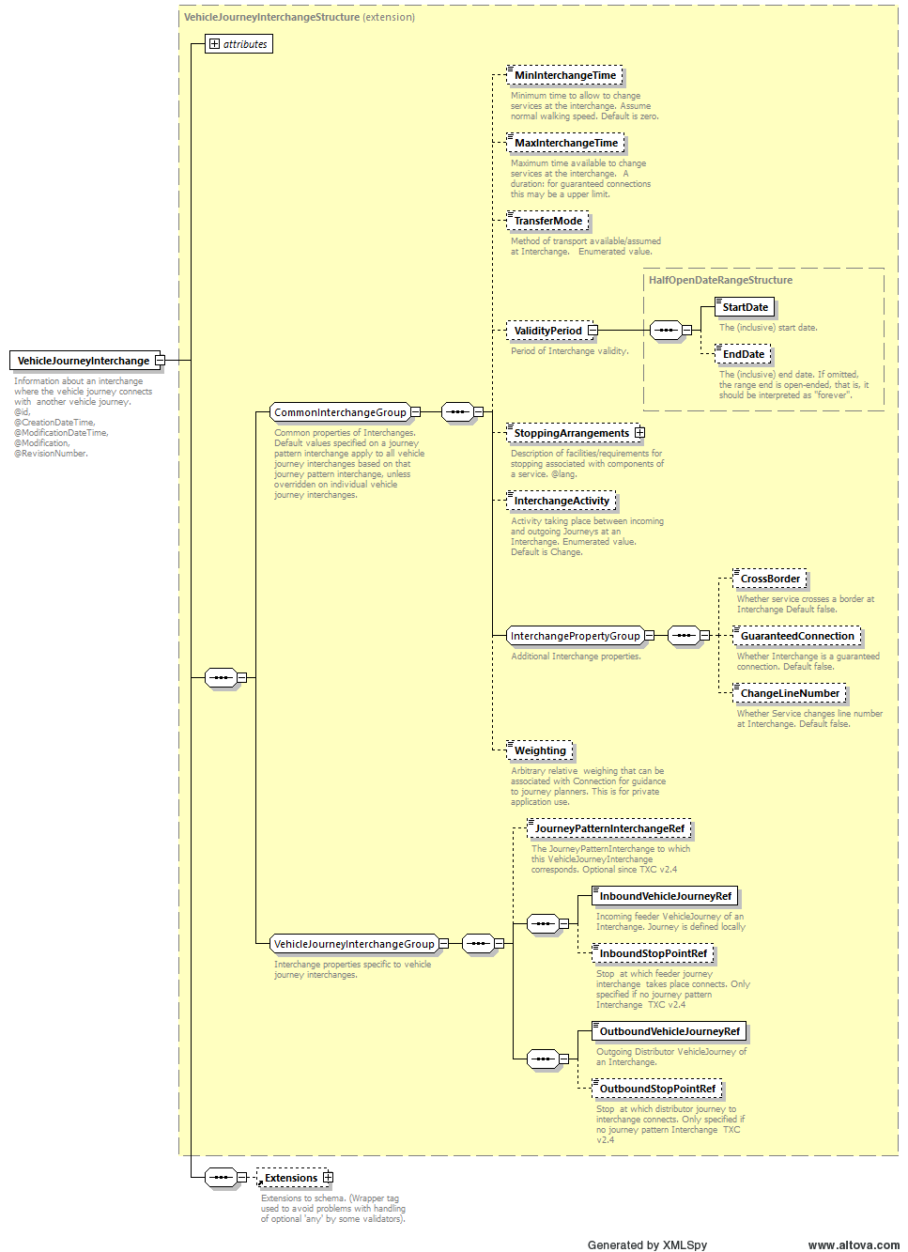
Figure 31 - The VehicleJourneyInterchange element

The following table shows the usage of the elements within a VehicleJourneyInterchange in TXC-PTI documents.
Table 27 - Usage of elements in a VehicleJourneyInterchange
Element Name |  | Data Type | Used in TXC-PTI
MinInterchangeTime |  | DurationType | The minimum permitted interchange time (default = 0 mins). Use where appropriate
MaxInterchangeTime |  | DurationType | The maximum time for a guaranteed connection. Use where appropriate.
TransferMode |  | AllModesEnumeration | Not used as assumed that the interchange mode is the mode of the service.
ValidityPeriod | StartDate | StartDateType | Not used as assumed that the interchange is valid for the duration of the OperatingPeriod.
ValidityPeriod | EndDate | EndDateType
StoppingArrangements |  | NaturalLanguageString | Not used.
InterchangeActivity |  | InterchangeActivity  Enumeration | Mandated in TXC-PTI interchanges. Describes the interchange as follows:  transferOnly not used.  change used for change of vehicle.  through used to stay on vehicle.  split not used.  join not used.
CrossBorder |  | boolean | Optional.
GuaranteedConnection |  | boolean | Mandated in TXC-PTI interchanges. Set to true for a guaranteed connection which require changes of vehicle, or for through connections with the same line name. False otherwise.
ChangeLineNumber |  | boolean | Mandated in TXC-PTI interchanges. Set to true where a through connection changes line name. False otherwise.
Weighting |  | integer | Optional.
JourneyPatternInterchangeRef |  | JourneyPatternInterchange  IdType | Optional.
InboundVehicleJourneyRef |  | VehicleJourneyRef  Structure | Mandated by schema. Reference to the feeder vehicle journey
InboundStopPointRef |  | StopPointRefStructure | Yes, shall be included. Reference to the stop point at which the interchange takes place.
OutboundVehicleJourneyRef |  | VehicleJourneyCodeType | Mandated by schema. Reference to the distrubutor vehicle journey
OutboundStopPointRef |  | StopPointRefStructure | Yes, shall be included. Reference to the stop point at which the interchange takes place.

    - Example of a vehicle journey interchange
The following example shows how an interchange might be defined between two trips at a vehicle journey level. For comparison, the same First in Leicester lines 16 from the example of the journey pattern interchange in section 5.3.6.3 has been used.
Line 16 has connections between two different vehicle journeys in different directions, connecting at NaPTAN stop reference 269039050. As before, note here that the direction of the line implied by the vehicle journey reference (showing OB for outbound and IB for inbound) is not the same as the usage of those terms in the interchange. Inbound in the interchange is for the incoming, feeder trip while outbound is for the outgoing, distributor trip.

<VehicleJourneyInterchange>
  - <MinInterchangeTime>PT0M</MinInterchangeTime>
  - <InterchangeActivity>through</InterchangeActivity>
  - <GuaranteedConnection>true</GuaranteedConnection>
  - <InboundVehicleJourneyRef>VJ1-MF-OB-1</InboundVehicleJourneyRef>
  - <InboundStopPointRef>269039050</InboundStopPointRef>
  - <OutboundVehicleJourneyRef>VJ17-MF-IB-2</OutboundVehicleJourneyRef>
  - <OutboundStopPointRef>269039050</OutboundStopPointRef>
</VehicleJourneyInterchange>

  - Real-time information
    - Introduction
In a TXC-PTI document, information to support real time information shall be included where available. While this is not public-facing information, and TXC-PTI has been designed around information that is directly relevant to the public, these elements are nevertheless an important part of the information feeding real time systems.
There are undoubted tensions between the need to provide timely notice of timetable changes and the (generally much later) allocation of vehicle duty schedules to the timetables. For this reason, the real time information is not mandatory in TXC-PTI, although the prompt, early inclusion of this information is strongly recommended
For the avoidance of doubt, TXC-PTI will mandate that, where this information is provided, it shall use the same references for the same elements that are used in SIRI-VM feeds.

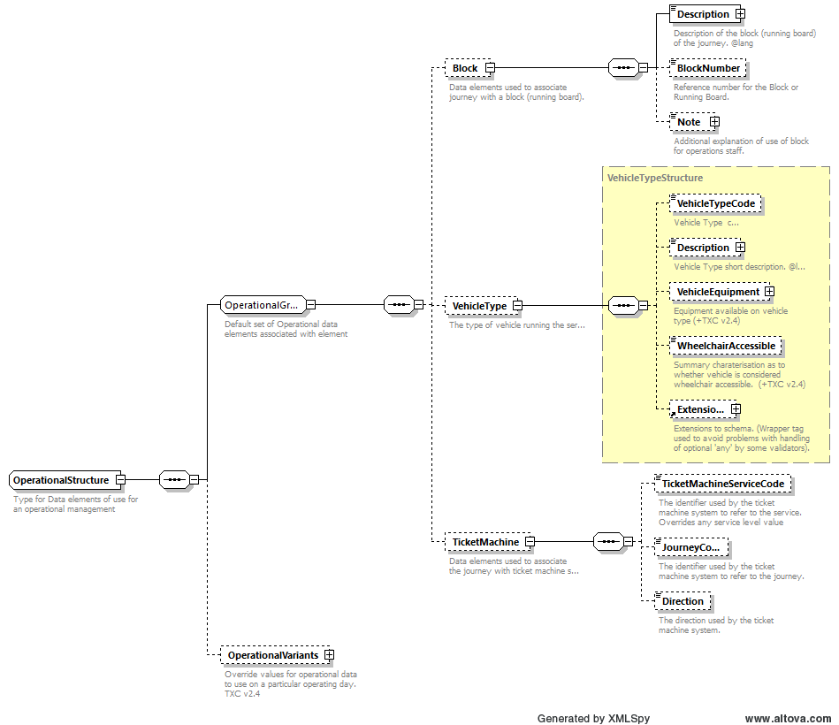
Figure 32 - The OperationalStructure supporting real time elements

Elements that may be populated in TXC-PTI include LayoverPoint and GarageRef, together with their linked dead runs (StartDeadRun and EndDeadRun), and the Block and TicketMachine elements within Operational element.
OperationalVariants, however, shall not be included. Where there are variants, these are best described using specific vehicle journeys.
In common with the principle of explicit declarations, where these are included, they shall be fully declared as part of a VehicleJourney, and not elsewhere.
➲
It is recommended that, in TXC-PTI, real time elements are provided as soon as they become available.
➲
Where real time information is provided, references in TXC-PTI shall match with equivalent references in SIRI-VM feeds.

The provision of Block is important for data consumers to be able to use in order to match across different data types. This enables data consumers to improve their journey predictions for passengers by considering cross journey predictions. Meaning if a vehicle is late on a journey, the next journey is likely to also be running late.
BODS recognises that Block information may not be available at the time of initial submission to BODS and or registration. The Data Quality reports observation identifies if the service is valid in the next week, and when it is valid it contains block numbers. The block number needs to be the same as the corresponding object in the bus location data field 'BlockRef'.
Block number is also known as bus workings number, most frequently populated using running board information. It's a unique identifier or code (usually a simple number) that is used for all the journeys an individual bus is scheduled to work.
If an operator does not have a documented running board, they can create one by allocating each of their vehicles a 'code'. For each of the journeys operated by the same vehicle, the journey should be given a consistent identifier as the input for both the TransXChange (BlockNumber) and SIRI-VM (BlockRef). For example, Vehicle 1, could have block number = 1 allocated to all the journeys that will be completed by vehicle 1.

    - Layover points
Layover points specify places, normally not bus stops, where buses will wait between trips. They also specify for how long the bus will remain at that location. They are useful in real time information systems to predict recovery times, delays to follow-on trips, etc.
A LayoverPoint can be specified at the JourneyPattern level, where it shall be used without further modification on all the VehicleJourneys that reference that JourneyPattern. Alternatively, it can be specified within the relevant VehicleJourney.
A LayoverPoint doesn’t specify where in the trip the vehicle lays over. In order to provide timing information to real time systems, the layover point shall be used in an EndDeadRun (where the vehicle transits empty to the layover point at the end of a VehicleJourney) and a StartDeadRun (where the vehicle transits empty from the layover point to the start of the next VehicleJourney).

Table 28 - Permitted usage of elements within a LayoverPoint
Element Name | Data Type | Used in TXC-PTI
Duration | DurationType | Mandated if LayoverPoint is included
Name | NaturalLanguageString | Mandated if LayoverPoint is included
Location | LocationStructure | Mandated if LayoverPoint is included, indicating the coordinates of the layover point. For LocationStructure see section 7.4
MinimumDuration | DurationType | Optional

    - Dead runs
Dead runs in a VehicleJourney are similarly helpful for real time systems to estimate times for following trips. TXC provides both a StartDeadRun and an EndDeadRun for dead runs at the start and end of trips, and these are both allowable in TXC-PTI. Dead runs can take place from garage to the first stop for that vehicle, from the last stop for that vehicle to the garage, or between stops at the end of one trip and the start of another.
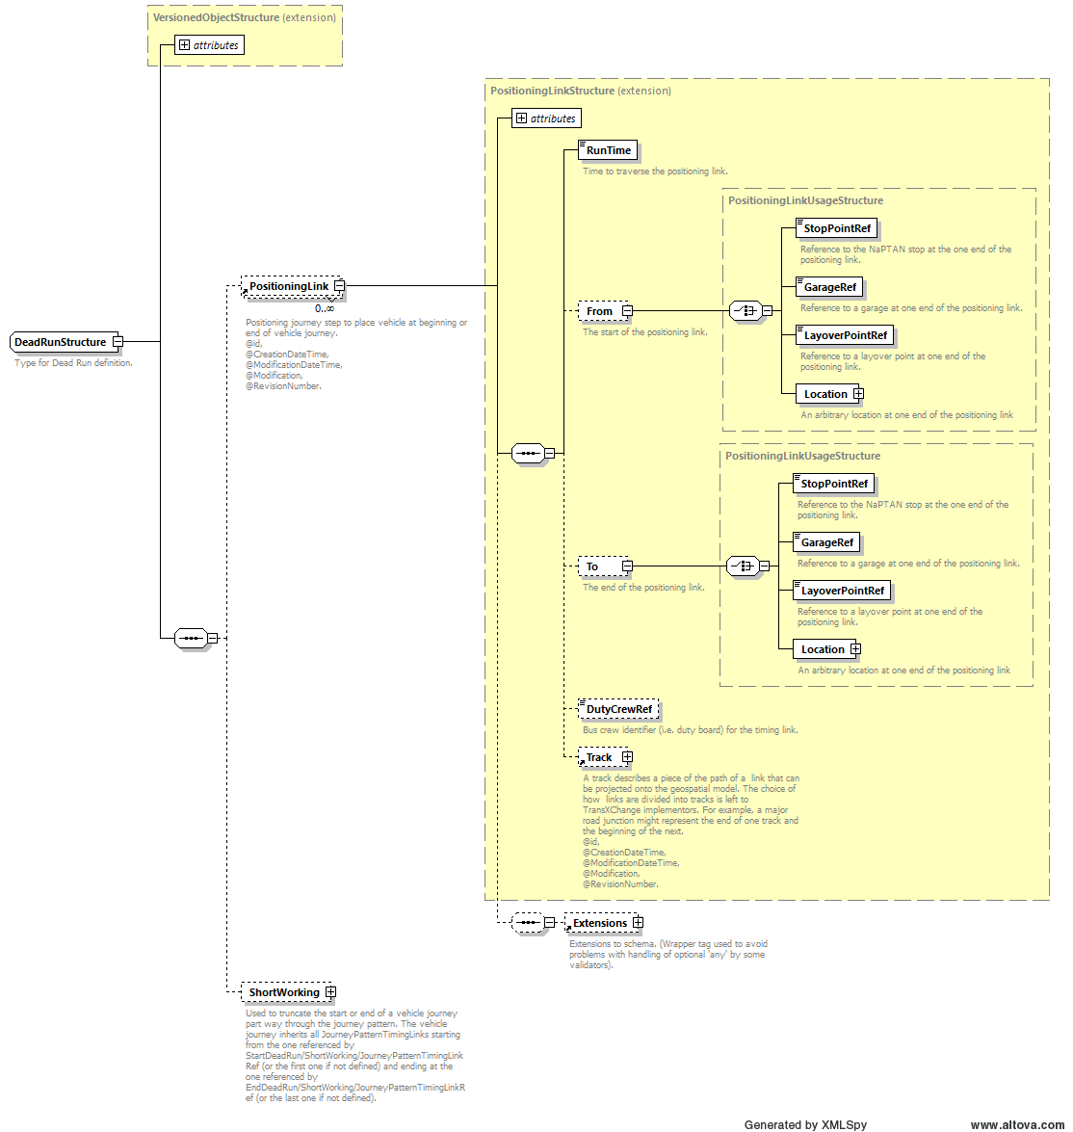
Figure 33 - The DeadRun structure
The structure of a dead run is shown in Figure 33 above. In TXC-PTI:
- there shall be a PositioningLink, which shall:
  - have a RunTime describing the run time between the From and To points;
  - have From and To elements, each of which shall be populated with either a StopPointRef, a GarageRef, a LayoverPoint, or an arbitrary Location, although this last is discouraged in TXC-PTI unless absolutely necessary.
  - As with route links, the use of Track element to describe the actual path that the vehicle takes is strongly recommended, but not mandatory in TXC-PTI.
- ShortWorking shall not be used. Instead, a JourneyPattern which fully defines the short working shall be defined.
Given a specific time in TXC, and with a structure comprised of link run times, a system will calculate a call time at any given point by adding all of the run times and wait times together and using the result as an offset from the departure time. There is no expectation that a system will have to subtract anything. On this basis, for the avoidance of doubt, TXC-PTI defines the DepartureTime of a VehicleJourney as either:
- the departure time from the first stop on the VehicleJourney, where there is no StartDeadRun; or
- the departure time of the StartDeadRun, where there is a StartDeadRun.

- Flexible services
  - Declaring a flexible service
A FlexibleService is constructed, at a high level, in essentially the same way as a StandardService, and forms part of the Service, generally replacing the StandardService. In a FlexibleService there is a FlexibleJourneyPattern instead of a JourneyPattern. For this reason, a FlexibleService in TXC-PTI will have the same constraints as a StandardService, and a FlexibleService shall have at least one FlexibleJourneyPattern.
➲
In TXC-PTI, a flexible service shall have a FlexibleService which shall consist of at least one FlexibleJourneyPattern.

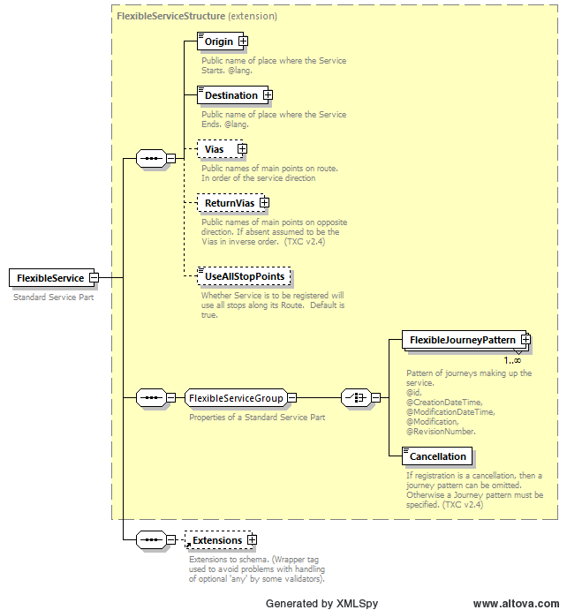
Figure 34 - The FlexibleService element

  - The FlexibleJourneyPattern element
At the top level, there is a high degree of commonality between a standard (non-flexible) service and a flexible service. The CommonInterchangeGroup is, in fact, common between both and a flexible service shall therefore follow the same rules for these elements – see section 8.2.
Beyond that, the flexible service is defined solely as an ordered set of stops, using the StopPointsInSequence element, and information shall be provided as to the booking arrangements needed to book the flexible service.
TXC-PTI does not need, at this time, to specify how these elements shall be completed. This will be the subject of a later revision.
➲
In TXC-PTI, a FlexibleJourneyPattern shall consist of a set of stopping points, and shall provide information as to how the service shall be booked.

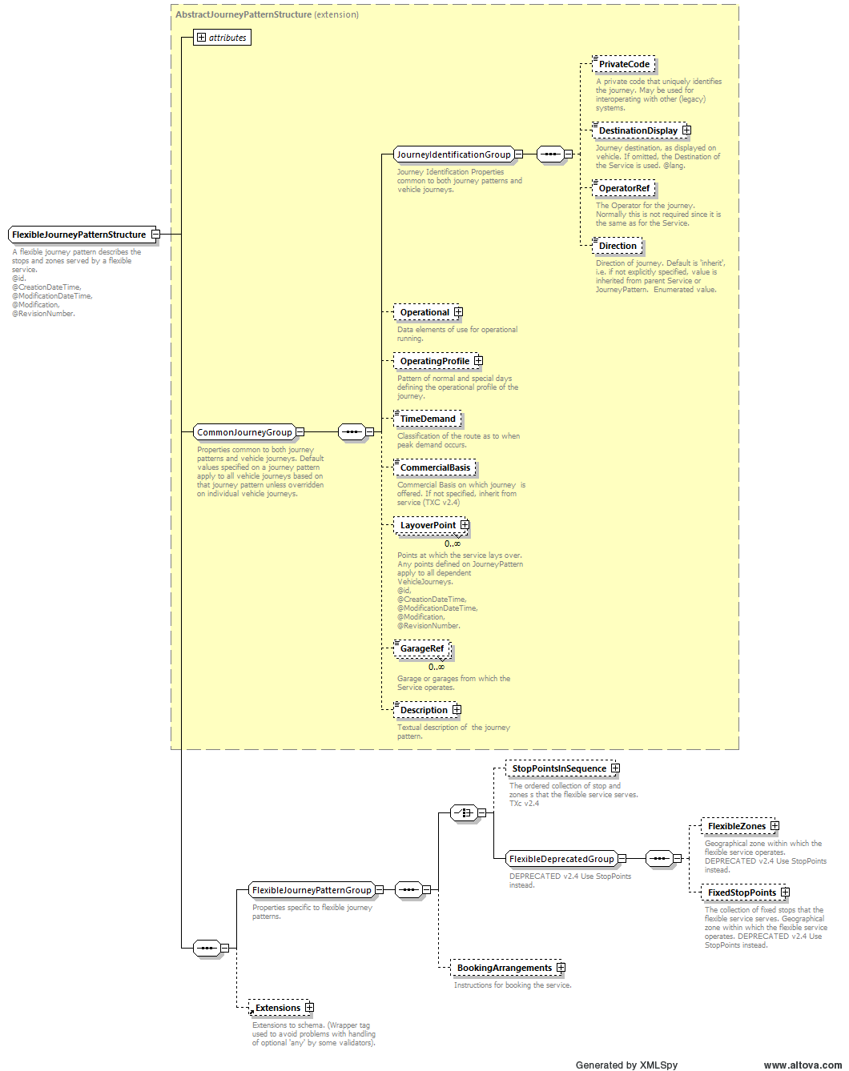
Figure 35 - The flexible journey pattern structure

